SNAP Helps New Yorkers Buy Food
The New York State Office of Temporary and Disability Assistance’s Nutrition Navigators program provides SNAP outreach and application assistance through SNAP Navigators based in local organizations across the state. Navigators answer eligibility questions, help people gather documents and complete applications, and connect families with other food assistance programs.
SNAP Navigators, statewide partners, and community organizations can use this toolkit to promote navigator services to families who may be eligible for SNAP and to the professionals who can refer them. The messages in this toolkit encourage New Yorkers to connect with a SNAP Navigator for free, confidential help applying for and keeping SNAP benefits. The toolkit includes:
- Social media graphics
- Social media captions for SNAP Navigators
- Social media captions for statewide and community partners
- Sample outreach language for SNAP Navigators
- Sample outreach language for statewide and community partners

Graphics
Right-click on an image to save it to your computer. Vertical graphics are sized for optimal display on Instagram profile grids.
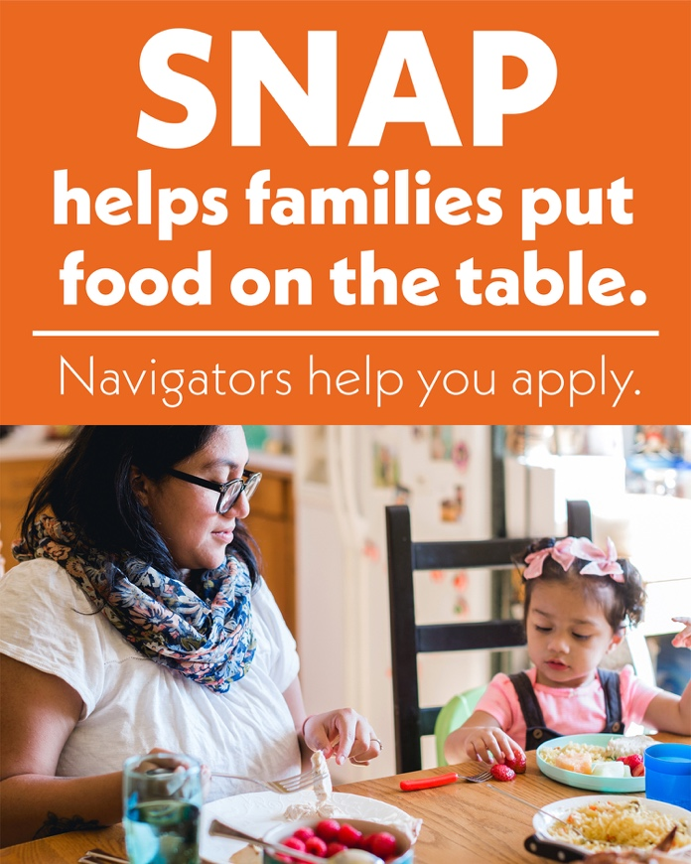
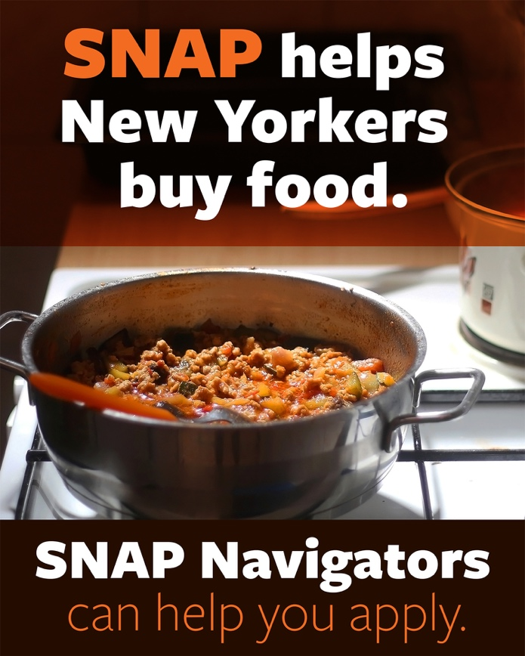

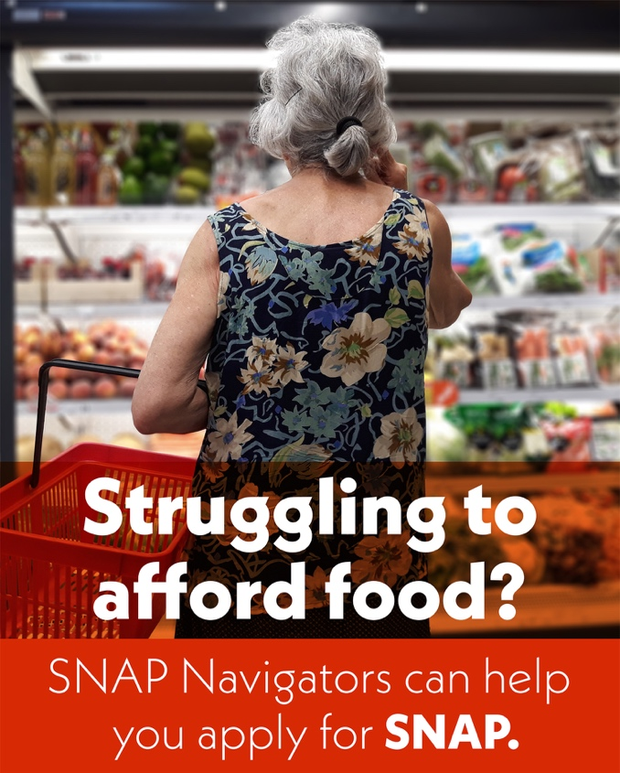
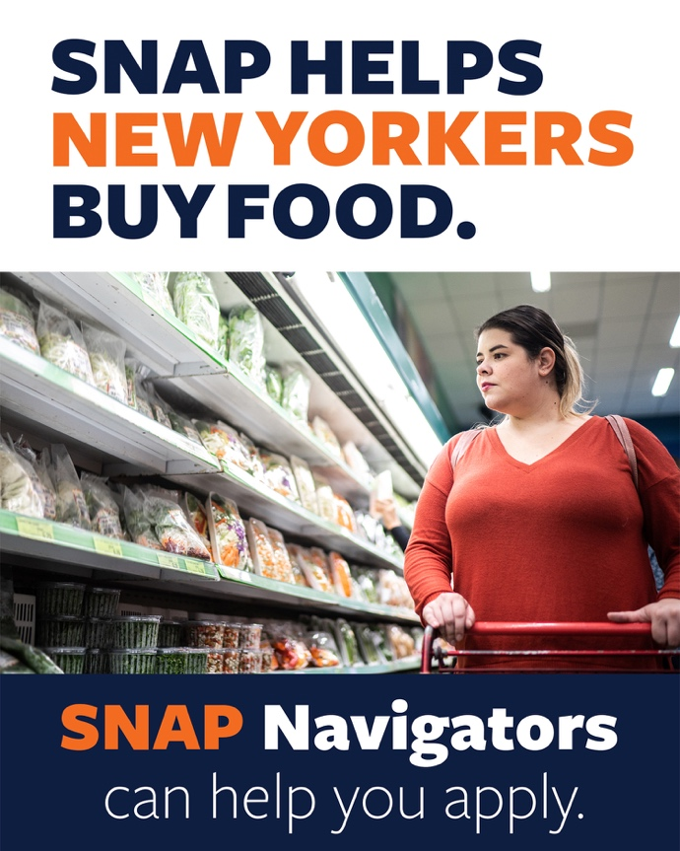
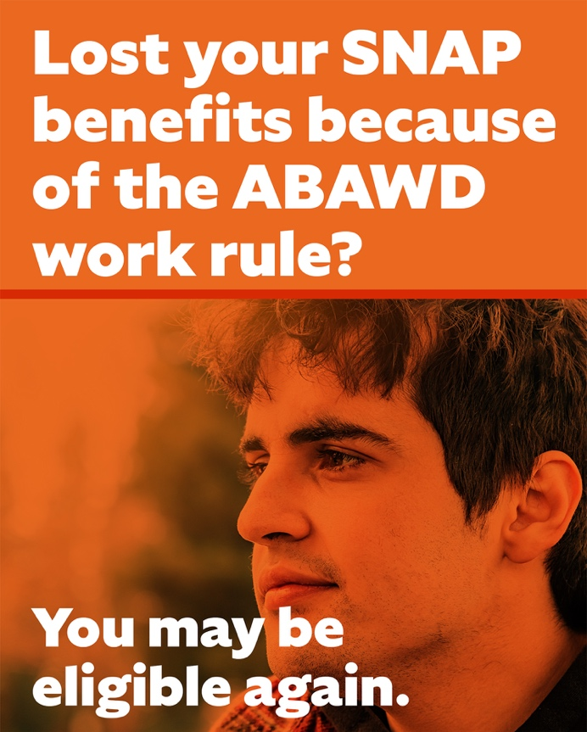
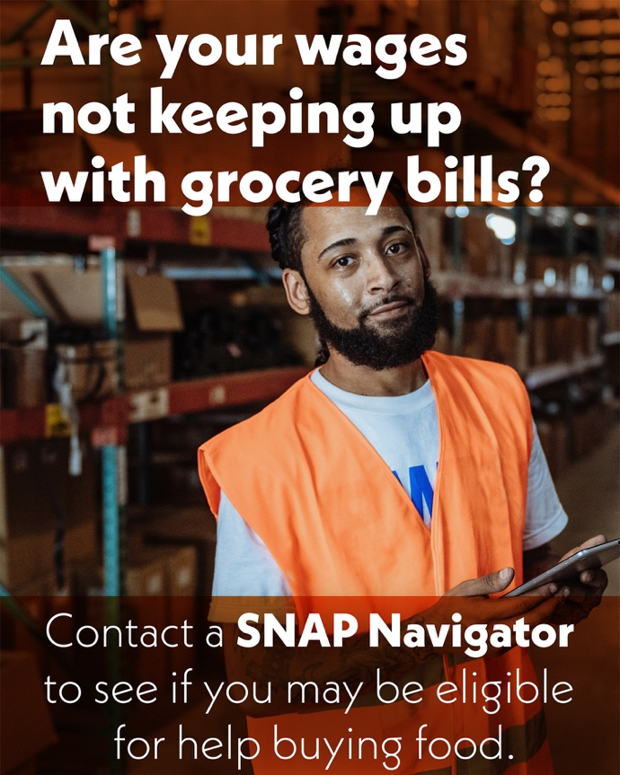

Social media captions for SNAP Navigators
Customize captions for your program or community and pair with a graphic above.
SNAP helps families put food on the table with monthly benefits that can be used at grocery stores, farmers markets, and other places that accept EBT. Need help with SNAP? Our SNAP Navigators can answer your questions, tell you if you may be eligible, and help you apply.
📞 [Phone]
📧 [Email]
🔗 [Website]
Is it getting harder to put food on the table? See if SNAP can help stretch your grocery budget. We can tell you if you may be eligible, help you gather paperwork, and walk you through every step of the application process. Reach out to one of our SNAP Navigators today! It's free and confidential. [Phone], [Email], or [Website].
As part of the New York State Office of Temporary and Disability Assistance’s Nutrition Navigators program, our Navigators offer free, confidential help with SNAP. We can tell you if you may be eligible and help you apply. If SNAP work requirements apply to you, we’ll also explain what you need to do to keep your benefits. Contact us at [Phone], [Email], or [Website] for free, confidential help with SNAP.
Navigating the SNAP application process can feel overwhelming. You don't have to do it alone. Our SNAP Navigators can answer your questions, tell you if you may be eligible, and help you apply. We can also connect you with other food assistance programs, like WIC and summer meals. Get in touch for free, confidential help today. [Phone], [Email], or [Website].
A job loss, a new baby, or a cut in hours at work can leave you with less to spend at the grocery store. If your income or household has changed recently, you may now qualify for SNAP. We can tell you if you may be eligible, help you gather documents, and guide you through the application process. Contact our SNAP Navigators for free and confidential help at [Phone], [Email], or [Website].
Some SNAP participants have to meet work requirements to keep their benefits. If you’re not sure whether these rules apply to you, our SNAP Navigators can help. We’ll explain what’s required and what you need to do to keep your benefits. Our help is free and confidential. Contact us at [Phone], [Email], or [Website].
Lost SNAP because of work rules? You may be eligible again. If you lost benefits because of these rules before October 1, 2026, you can reapply or ask to be added back to your household’s case. That gives you more time to find work, start a training program, or take part in other activities that meet the requirement. Our SNAP Navigators can help you understand your options and reapply. Contact us at [Phone], [Email], or [Website].

Social media captions for partners
Customize captions for your program or community and pair with a graphic above.
Is it getting harder to put food on the table? SNAP helps eligible families stretch their food budget. New York’s SNAP Navigators can help you apply. They can tell you if you may be eligible, help you gather paperwork, and walk you through every step of the application process. Find a navigator near you at FoodHelpNY.org.
SNAP helps families put food on the table, but the application process can seem overwhelming. SNAP Navigators offer one-on-one assistance. They can tell you if you may be eligible, help you complete and submit your application, and track its progress. Navigators are based in community organizations around the state. Find one near you at FoodHelpNY.org.
No one should have to choose between food and other essentials. SNAP helps families afford groceries, so they don’t have to make those trade-offs. SNAP Navigators offer free and confidential help with SNAP around New York State. They can tell you if your family may be eligible and help you apply. Find one near you at FoodHelpNY.org.
Some SNAP participants have to meet work requirements to keep their benefits. New York’s SNAP Navigators can explain whether the requirements apply to you and what you need to do. Their help is free and confidential. Find a SNAP Navigator at FoodHelpNY.org.
Lost SNAP because of work rules? You may be eligible again. If you lost benefits before October 1, 2026, you can reapply or ask to be added back to your household’s case. That gives you more time to find work, start a training program, or take part in other activities that meet the requirement. SNAP Navigators can help you understand your options and reapply. Find free and confidential help with SNAP at FoodHelpNY.org.
Through the New York State Office of Temporary and Disability Assistance’s Nutrition Navigators program, New Yorkers can get free, confidential help with SNAP from Navigators at community organizations around the state. They can tell you if you may be eligible, help you gather documents and apply, and help you keep your benefits. Visit FoodHelpNY.org to find a SNAP Navigator near you.
You can help more New Yorkers get connected to SNAP. Refer families and community partners to FoodHelpNY.org. New Yorkers can use it to find a SNAP Navigator for confidential, one-on-one eligibility and application assistance at no cost. Navigators can also connect families with other programs that help with food.
SNAP can be a lifeline for families who need help putting food on the table. SNAP Navigators are available in communities around New York to answer eligibility questions and guide families through the application process. It’s free and confidential. Visit FoodHelpNY.org to find a navigator near you.

Sample outreach language for SNAP Navigators
Sample language for websites, newsletters, or emails. Customize for your program or community.
With rising costs, many families are having a harder time putting food on the table. SNAP helps eligible families afford more food with monthly benefits on an EBT card. Families can use their EBT card like a debit card to buy groceries at participating stores and farmers markets. Some stores also accept SNAP for online grocery orders.
Many working families, older adults, people with disabilities, and households with children qualify for SNAP. Eligibility depends on your household size, income, and certain expenses. You may be eligible even if you have a job. If you applied in the past and weren’t approved, it’s worth checking again.
If you think SNAP could help you, our SNAP Navigators can guide you through the application process. We’ll tell you if you may be eligible, help you gather the right documents, and help you complete and submit your application. Beyond the application, we can explain whether work requirements apply to you and what you need to do to keep your benefits. We can also connect you to other nutrition programs, such as WIC and Summer EBT.
Contact us at [Phone], [Email], or [Website] for free and confidential help with SNAP.

Sample outreach language for partners
Sample language for websites, newsletters, or emails. Customize for your program or community.
With rising costs, many families are having a harder time putting food on the table. SNAP helps eligible families afford more food with monthly benefits on an EBT card. Families can use their EBT card like a debit card to buy groceries at participating stores and farmers markets. Some stores also accept SNAP for online grocery orders.
Many working families, older adults, people with disabilities, and households with children qualify for SNAP. Eligibility depends on your household size, income, and certain expenses. You may be eligible even if you have a job. If you applied in the past and weren’t approved, it’s worth checking again.
If you think SNAP could help you, a SNAP Navigator can guide you through the application process. Navigators are part of the New York State Office of Temporary and Disability Assistance’s Nutrition Navigators program and work at trusted community organizations across the state. They’ll tell you if you may be eligible, help you gather the right documents, and help you complete and submit your application. Beyond the application, Navigators can explain whether work requirements apply to you and what you need to do to keep your benefits. They can also connect you to other nutrition programs, such as WIC and Summer EBT.
Visit FoodHelpNY.org to find a SNAP Navigator near you for free and confidential help with SNAP. If you work with families who could use help with SNAP, refer them to FoodHelpNY.org to connect with a Navigator.

