Summer Food Resources:
A Toolkit for Schools and Community Organizations
When the school year ends, millions of New York kids lose access to free school meals. Nutrition supports—including summer meals, Summer EBT, the Supplemental Nutrition Assistance Program (SNAP), and WIC—can be a lifeline for families struggling to afford groceries.
Use the resources in this toolkit to help families learn about food resources available over summer break and beyond. Resources include:
- Sample language for newsletters, websites, email, and other communications
- Sample social media captions
- Graphics

Sample Language
Dear families,
When the school year ends, kids lose access to free school meals. If your family could use extra support over the summer, the following resources are available in our community:
SUMMER MEALS
During the summer, all kids and teens ages 18 and under can get free meals at nearby parks, community centers, libraries, and other locations. Many sites offer fun activities, and in rural areas, some locations offer grab-and-go meals. Starting in early July, you can find summer meal locations near you by visiting SummerMealsNY.org
SUMMER EBT
Summer EBT helps families with school-aged children buy groceries when school is out. Eligible children receive a $120 food benefit on an EBT card that can be used at grocery stores, farmers’ markets, and other retailers. Many children are automatically enrolled, but some will have to apply.
- Children automatically enrolled will receive a letter from the NYS Office of Temporary and Disability Assistance (NYSOTDA) with the date their benefits will be issued and the payment method. Families may also receive email and text message communication from NYSOTDA about their benefits.
- If your child is eligible but you have not received any communication from NYSOTDA by mid-June, apply by September 8, 2026.
- For more information, visit otda.ny.gov/programs/summer-ebt

SNAP
SNAP provides monthly benefits to buy food at grocery stores and farmers' markets. To see if your family may be eligible, visit SNAPHelpNY.org or text SNAPNY to 844-366-3435 and answer a few questions. In less than five minutes, you will learn if you may be eligible and how to apply. Free and confidential assistance is available to help you complete and submit your SNAP application.
WIC
If you are pregnant or raising kids under age five, WIC offers healthy food, nutrition and breastfeeding support, and other resources for your family. You may qualify if your income meets program limits or if you participate in Medicaid, SNAP, Head Start, Early Head Start, the Essential Plan, or TANF. Recent updates to the program, including virtual appointments and expanded food options, make it easier than ever to participate. Chat with Wanda, WIC’s bilingual virtual assistant, at WICHelpNY.org to get connected with a WIC office.

FOOD PANTRIES & OTHER RESOURCES
Find emergency food providers:
- The Food Pantries Food Connect Map: Find local food pantries, community meals, mobile food resources, and more.
- Feeding NYS Food Pantry Locator: Find food pantries, soup kitchens, and other food assistance resources near you.
Find food resources by phone:
- Call the USDA National Hunger Hotline at 1-866-3-HUNGRY or 1-877-8-HAMBRE (Spanish)
- Call 211 for New York State residents, or 311 in New York City
- Text “food” to 914-342-7744

Sample Social Media Captions
When school ends, kids lose access to free school meals. If your family could use extra support this summer, learn how summer meals, Summer EBT, SNAP, and WIC can help stretch grocery budgets and keep kids fed all summer: hungersolutionsny.org/find-food-help.
Without free school meals, summer grocery bills can add up fast. Programs like summer meals, Summer EBT, SNAP, and WIC can help families get the food they need during the summer and beyond. See what's available for your family at hungersolutionsny.org/find-food-help.
When school lets out, grocery bills go up for families who relied on free school meals. Resources in our community, like summer meals, Summer EBT, SNAP, and WIC, can help families put food on the table. Visit hungersolutionsny.org/find-food-help to learn more.
Need help with groceries this summer? Summer meals and Summer EBT can help kids get the food they need over break. Other resources—including SNAP and WIC—can also stretch your grocery budget and put more food on the table. See what's available for your family at hungersolutionsny.org/find-food-help.
Summer grocery bills add up fast when kids are home from school. SNAP helps families put food on the table with monthly benefits that can be used at grocery stores and farmers' markets. Summer meals, Summer EBT, and WIC can also help families get the food they need. Visit hungersolutionsny.org/find-food-help to learn more.
Graphics
Right-click on the graphic to save it to your computer.
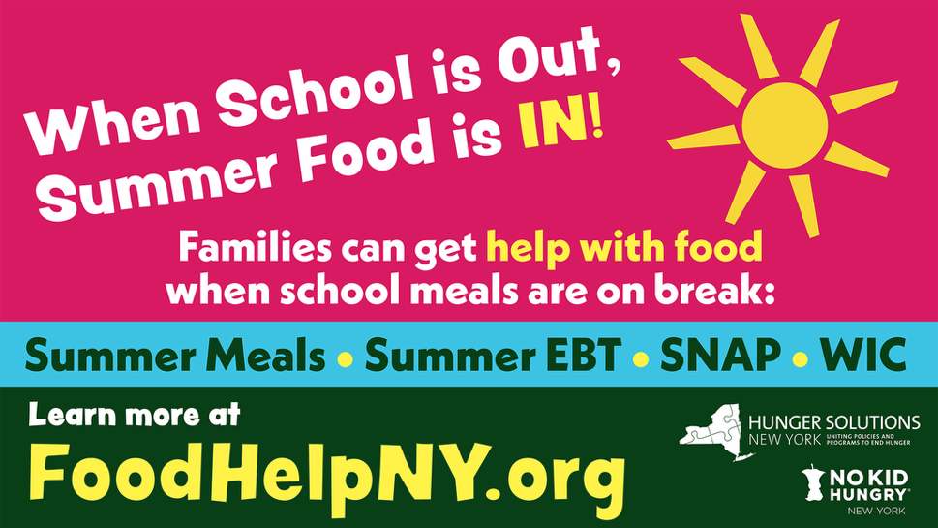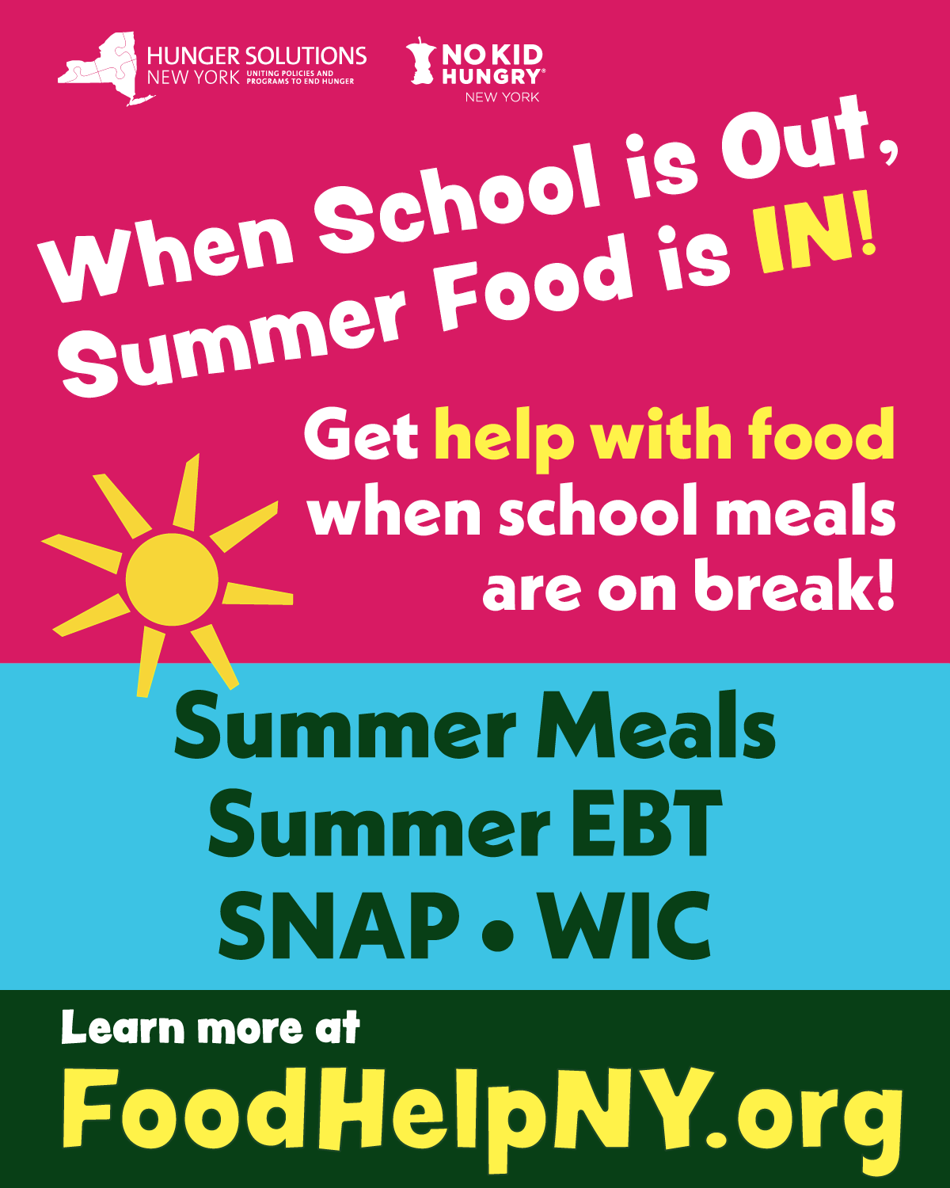
Carousel images
The images below are for a carousel post on Instagram, which allows users to share multiple photos or videos in a single post. Viewers can swipe (on mobile) or click (on desktop) to navigate through the carousel. This format is useful for sharing detailed information in a visually engaging way.
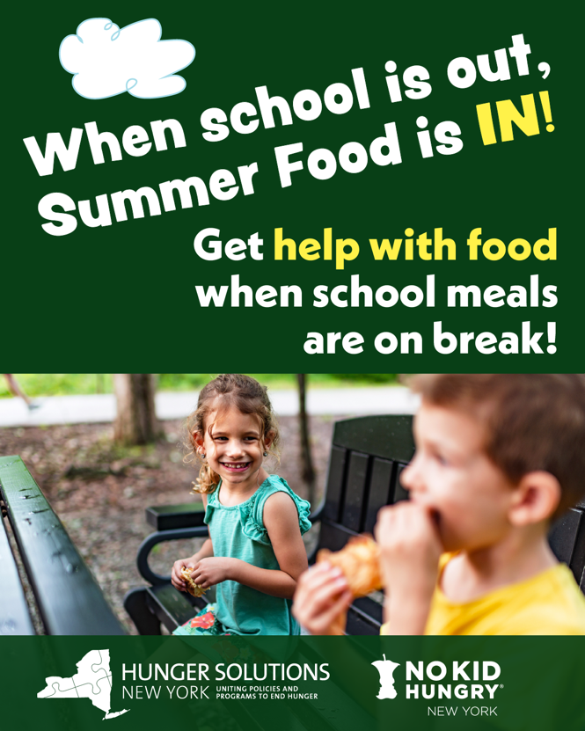
1
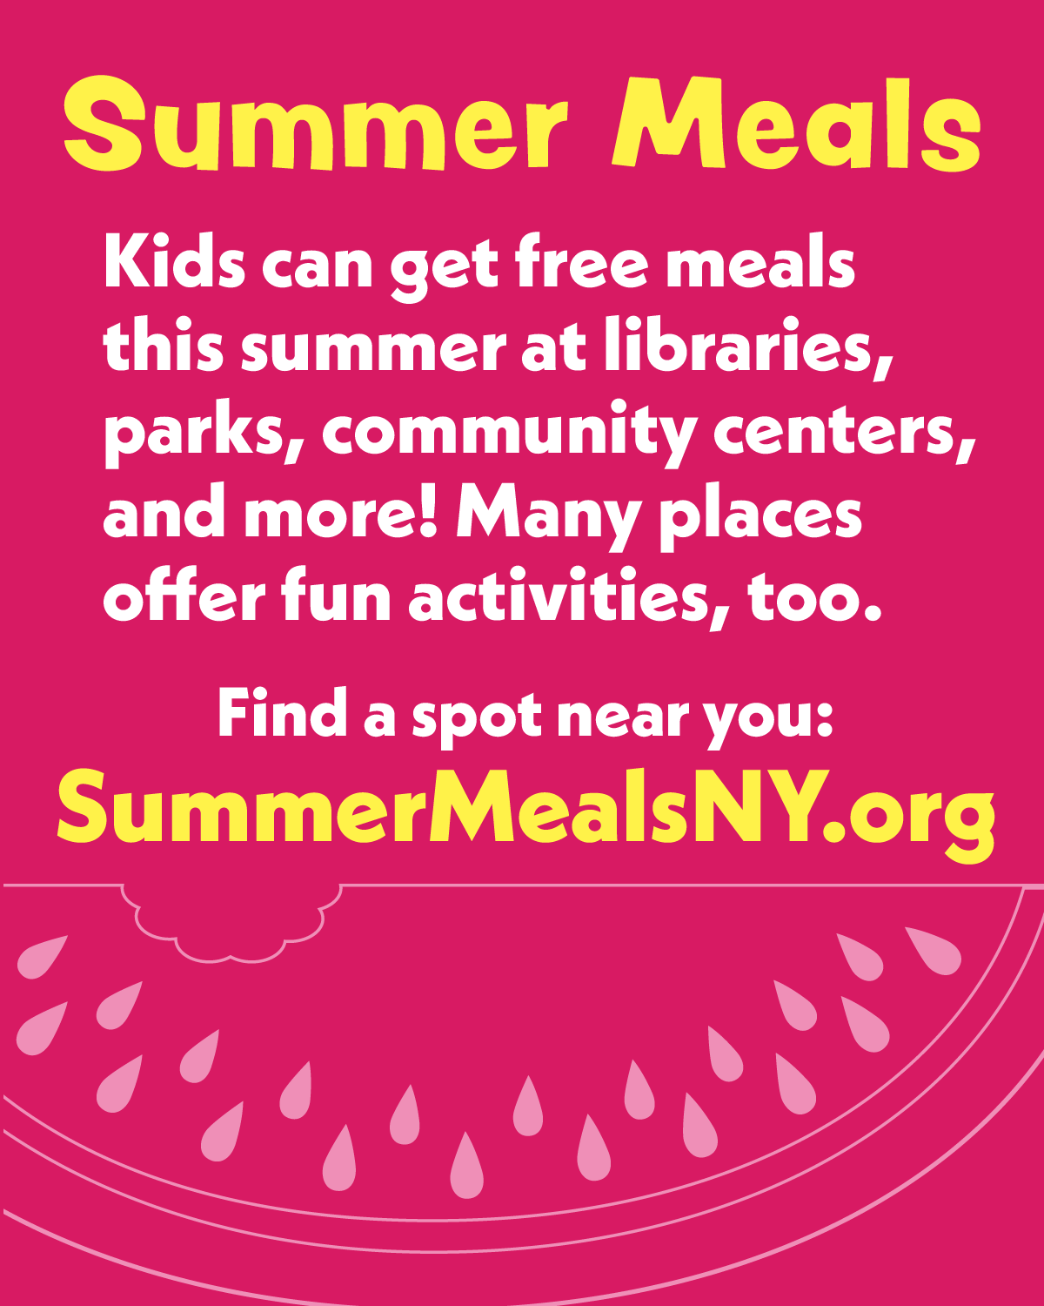
2
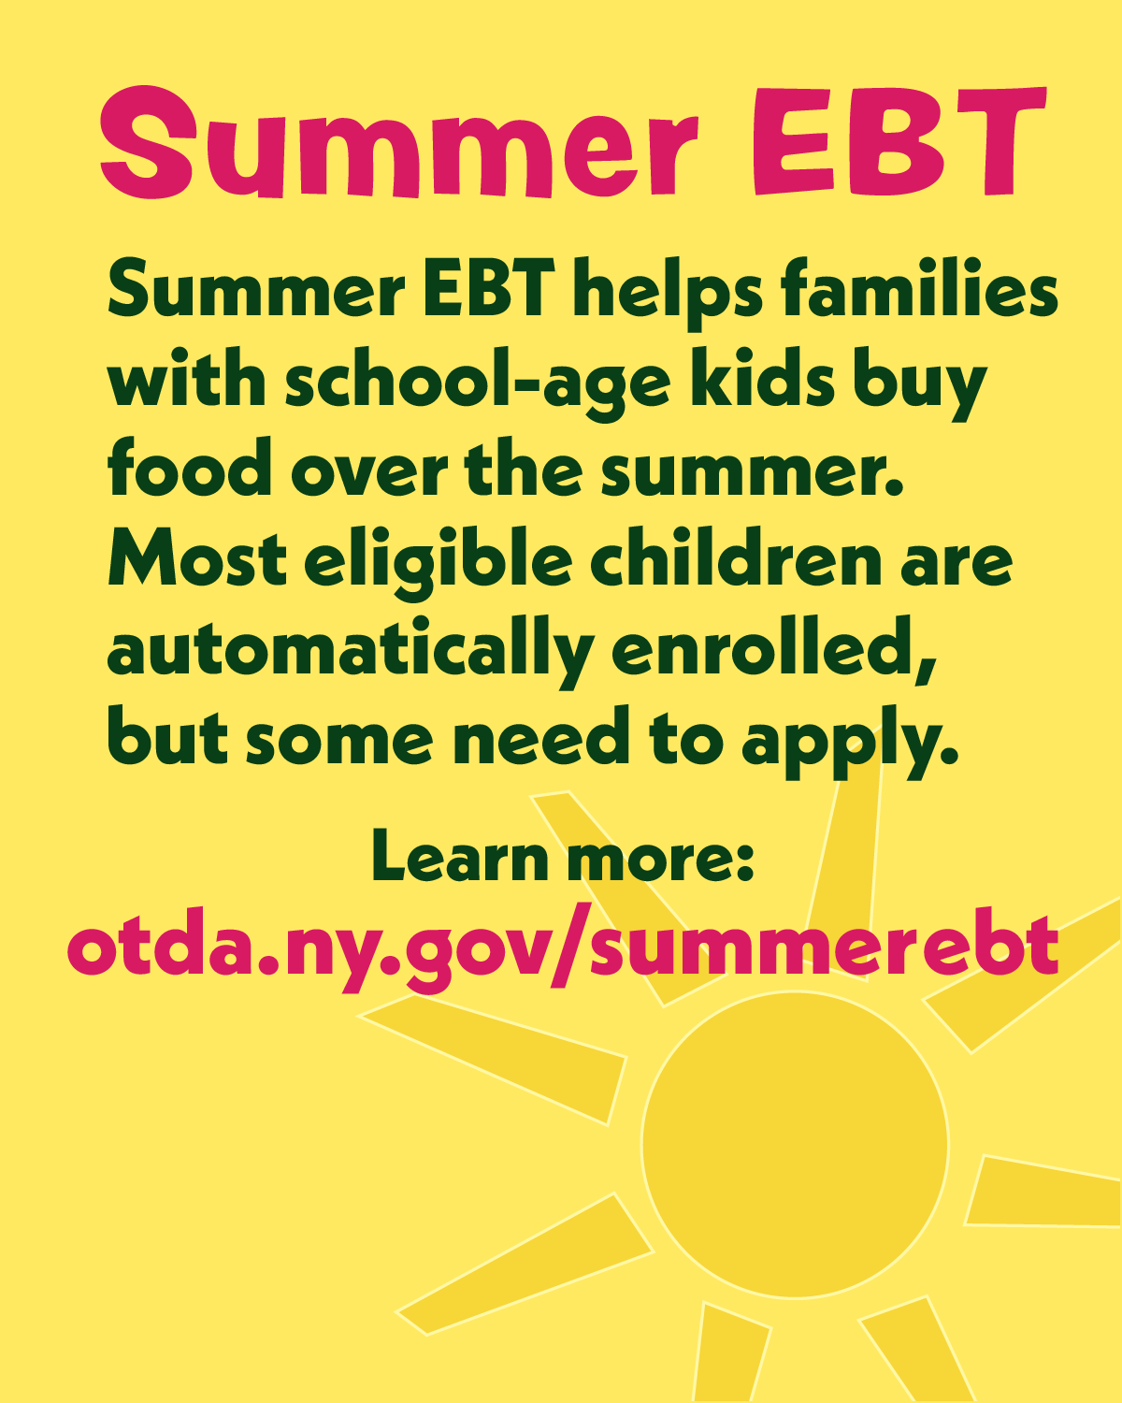
3
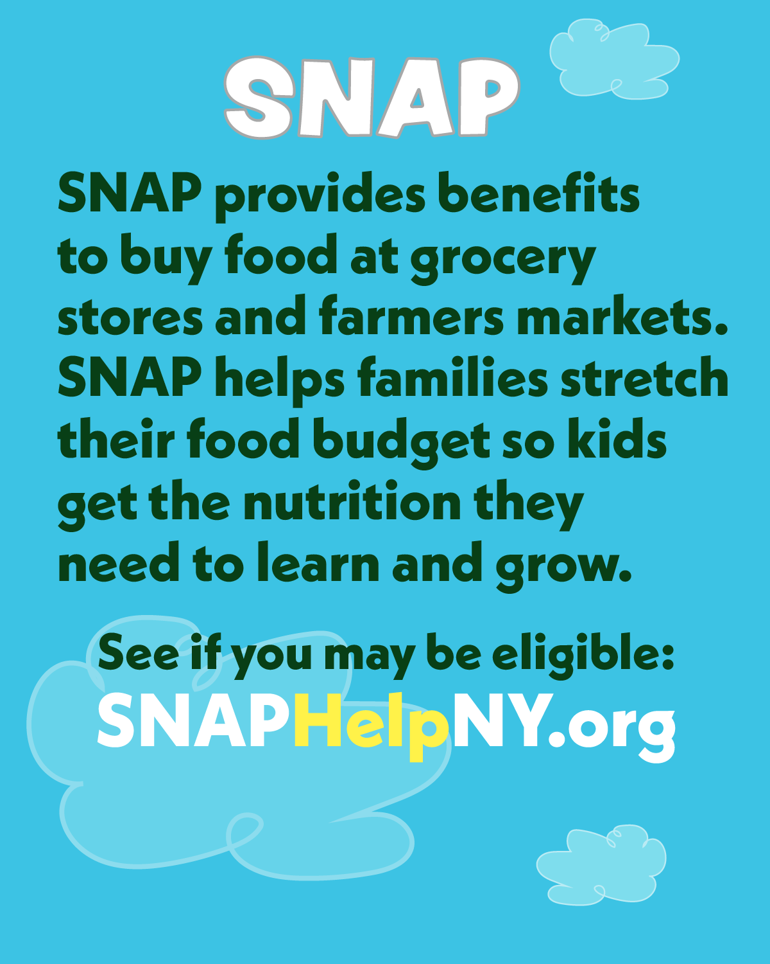
4
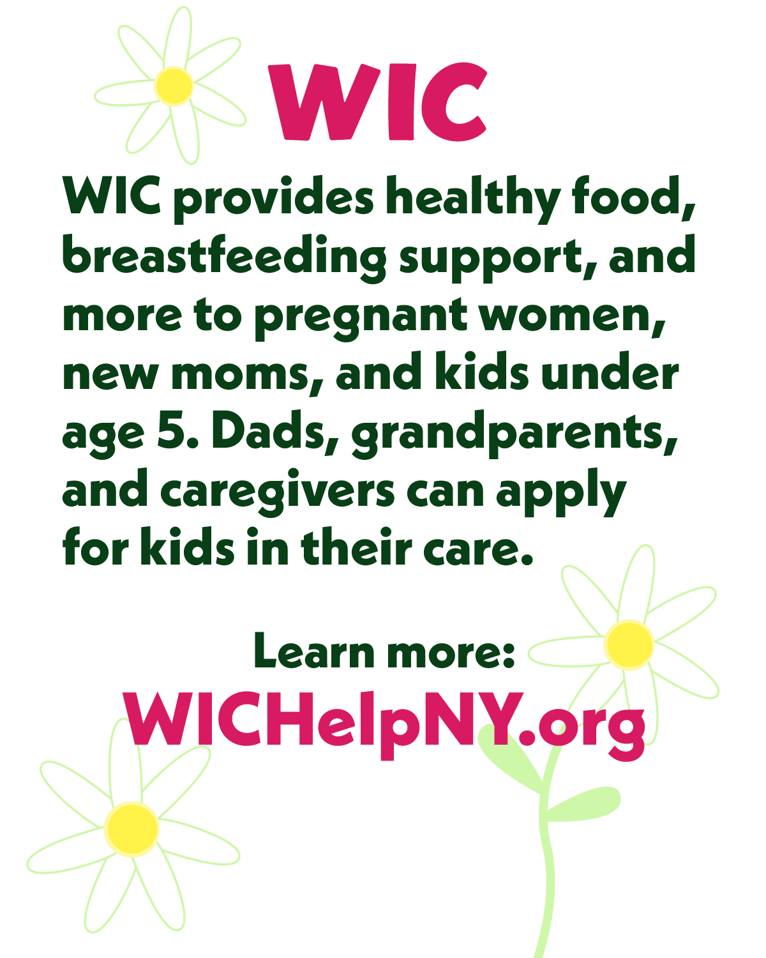
5

