CACFP Outreach Toolkit
The Child and Adult Care Food Program (CACFP) reimburses eligible childcare and afterschool program providers for serving meals and snacks to kids. The program is underutilized throughout New York. CACFP Sponsors and other organizations can use this toolkit to promote CACFP to potentially eligible providers.
This toolkit includes:
- Social media images
- Sample social media captions
- Outreach language
- Sample letter to providers in English and Spanish
- Additional resources

Social media images
Right click on images and save to your computer.

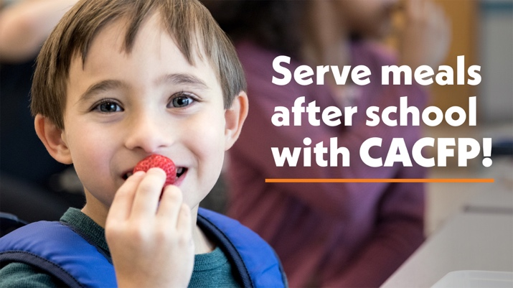
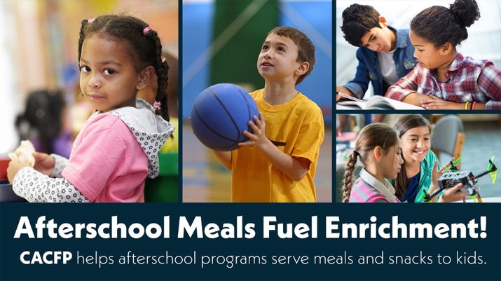
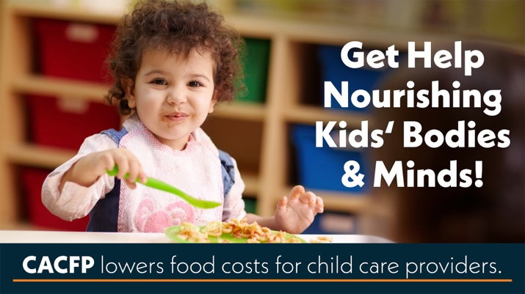
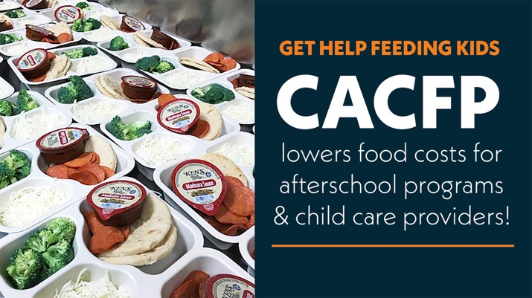
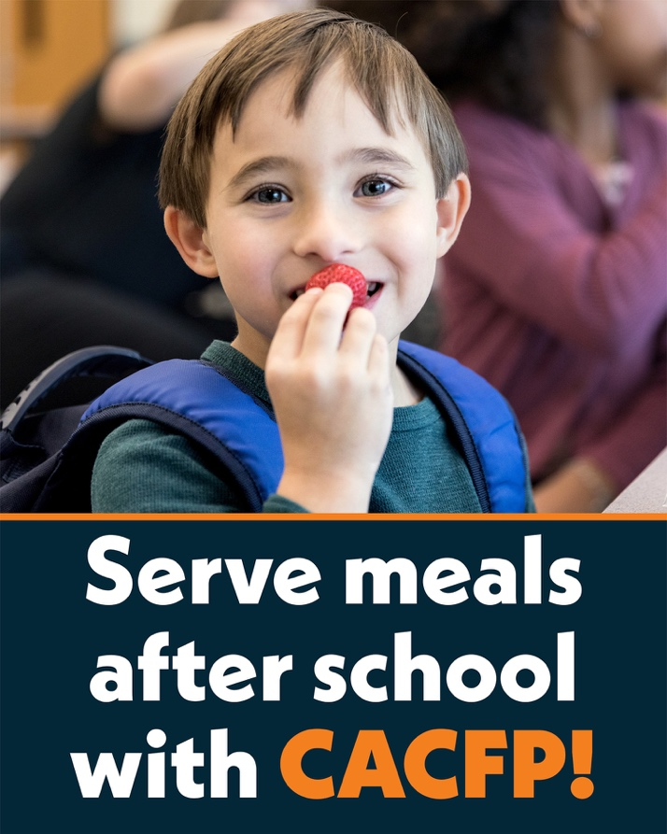
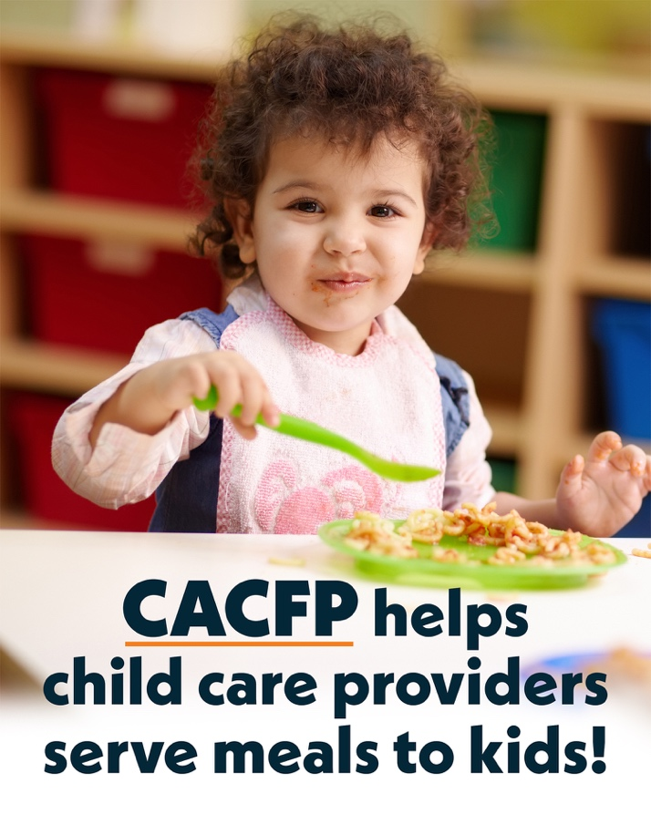
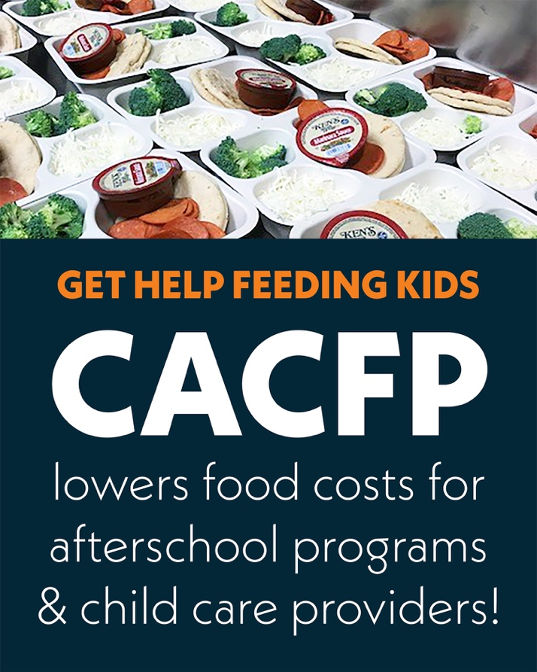
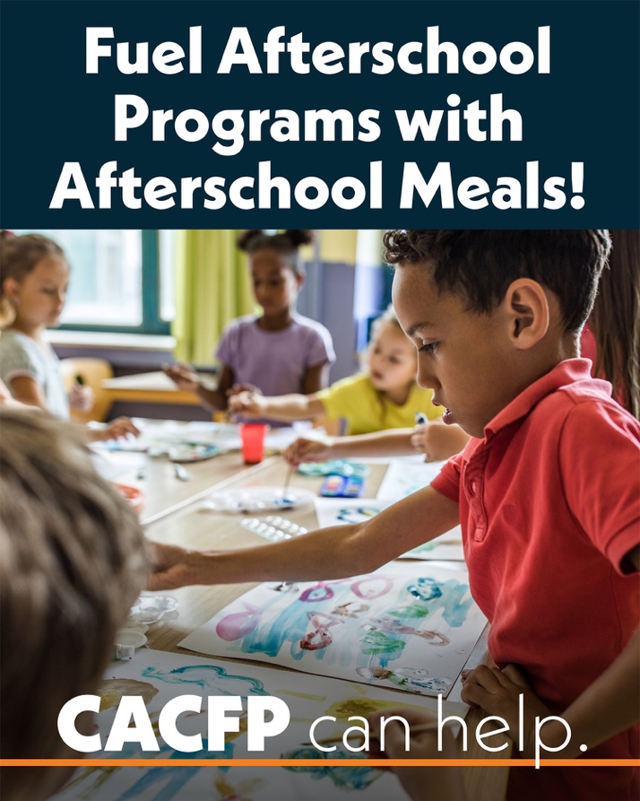

Sample Social Media Captions
Afterschool Meals
Afterschool programs work hard to support kids beyond the school day. CACFP can help by reimbursing eligible programs for serving healthy meals and snacks. Learn more at AfterschoolMealsNY.org.
After a full day of school, kids need nutritious food to fuel their busy afternoons. CACFP helps eligible afterschool programs offset food costs by reimbursing for meals and snacks. Learn how CACFP can support your program at AfterschoolMealsNY.org.
Does your afterschool program serve food? CACFP provides reimbursement to eligible programs for meals and snacks served after school. Learn more at AfterschoolMealsNY.org.
Across New York, afterschool programs use CACFP to receive reimbursement for nutritious meals and snacks. Learn more and see if your program may be eligible at AfterschoolMealsNY.org.
Afterschool program providers may be eligible for meal and snack reimbursement through CACFP. Learn more about how CACFP can lower your food costs and support access to nutritious food for kids at AfterschoolMealsNY.org.
Nourish students beyond the school day with afterschool meals through the Child and Adult Care Food Program (CACFP). Learn how CACFP can support your program at AfterschoolMealsNY.org.

Childcare Centers
Childcare providers play a vital role in children’s growth and development. CACFP can help eligible providers receive reimbursement for the meals and snacks that nourish the kids in their care. Learn more at ChildcareMealsNY.org.
CACFP can help childcare providers nourish growing bodies and minds. Eligible programs receive reimbursement for meals and snacks, making it easier to serve the nutritious food kids need to thrive. Learn more at ChildcareMealsNY.org.
Childcare providers know that every meal is an opportunity to support children’s health and learning, but serving nutritious food can be costly. CACFP helps eligible providers lower these costs through reimbursement for meals and snacks. Learn how CACFP can support your program at ChildcareMealsNY.org.
Many childcare providers qualify for CACFP to receive reimbursement for meals and snacks served in their program. CACFP lowers food costs and helps programs nourish the kids in their care. Child care centers and homes are able to participate. Learn more at ChildcareMealsNY.org.
Childcare providers may be eligible to receive reimbursement for serving healthy meals and snacks to children in their care through CACFP. Visit ChildcareMealsNY.org for more information.
Participating in CACFP is an indicator of quality care. Learn more about how childcare providers can qualify for reimbursement for serving healthy meals and snacks at ChildcareMealsNY.org.
Afterschool and Childcare Centers
CACFP can help lower the cost of meals and snacks in childcare and afterschool programs. Learn more about eligibility and participation at ChildcareMealsNY.org.
CACFP can help your childcare or afterschool program nourish the kids in your care. Eligible programs receive reimbursement for nutritious meals and snacks, reducing program costs and improving food access for kids. Learn more at ChildcareMealsNY.org.
Are you serving meals or snacks to kids in your childcare or afterschool program? Your program may qualify for reimbursement through CACFP. CACFP lowers food costs and helps programs nourish the kids in their care. Learn more about eligibility and how to apply at ChildcareMealsNY.org.
Kids need nutritious food to grow, learn, and stay focused through the day. CACFP can help eligible childcare or afterschool programs pay for meals and snacks served to kids. Learn more at ChildcareMealsNY.org.
CACFP helps afterschool and childcare providers pay for healthy meals and snacks for the kids in their care. Thousands of providers in New York participate, but many more are eligible. Learn more about eligibility and participation at ChildcareMealsNY.org.
The Child and Adult Care Food Program (CACFP) provides reimbursement to afterschool and childcare providers for serving healthy meals and snacks to children in their care. Learn more about eligibility and how to apply by visiting ChildcareMealsNY.org.

Sample Outreach Language
Use this language in newsletters, websites, flyers or other communications to providers.
Option 1
The Child and Adult Care Food Program (CACFP) reimburses eligible childcare and afterschool providers for serving healthy meals and snacks to kids in their care, reducing food costs for programs and supporting children’s access to food. The program is underutilized across New York State, and many eligible programs are not participating. Visit ChildcareMealsNY.org to learn about eligibility and participation.

Option 2
The Child and Adult Care Food Program (CACFP) provides reimbursement for healthy meals and snacks in childcare and afterschool settings. This helps support good nutrition, children’s development and learning, and is an indicator of quality care. To learn more about eligibility and next steps to apply, visit AfterschoolMealsNY.org or ChildcareMealsNY.org.
Sample Letter to Potentially Eligible Providers (English and Spanish)
Did you know you may be eligible to receive funds to provide meals and snacks to children in your care?
The Child and Adult Care Food Program (CACFP) is a federally funded initiative that reimburses childcare providers for serving healthy meals and snacks to children.
Meals served must include:
- Protein
- Grain
- Fruit
- Vegetable
- Milk
Learn more about meal requirements.
Other requirements of the program include keeping track of:
- Attendance
- Number of meals you serve
- Menus
- Receipts or proof of food purchased
- How much food is prepared and served, and
- Income information for families of children in your care.
Learn more about CACFP here.
Next steps:
To see if your program is eligible to participate, use the CACFP Pre-Screening Eligibility Tool.

¿Sabía que puede ser elegible para recibir fondos para proporcionar comidas y refrigerios a los niños bajo su cuidado?
El Programa de Alimentos para el Cuidado de Niños y Adultos (Child and Adult Care Food Program, CACFP) es una iniciativa financiada por el gobierno federal que proporciona un reembolso a los proveedores de cuidado infantil por servir comidas y refrigerios saludables a niños.
Las comidas servidas deben incluir:
- Proteínas
- Cereales
- Frutas
- Verduras
- Leche
Obtenga más información sobre los requisitos de las comidas
Otros requisitos del programa incluyen llevar un registro de:
- La asistencia
- La cantidad de comidas que sirve
- Los menús
- Los recibos o comprobantes de alimentos comprados
- La cantidad de alimentos que se preparan y se sirven
- La información sobre los ingresos de las familias de los niños bajo su cuidado
Obtenga más información sobre CACFP aquí.
Próximos pasos:
Puede encontrar un patrocinador local llamando al 1-800-522-5006 (Línea directa de Growing Up Healthy).

Additional Resources
Find information about CACFP from Hunger Solutions New York at ChildcareMealsNY.org.
Find about CACFP from the New York State Department of Health at: https://www.health.ny.gov/prevention/nutrition/cacfp/
Request free print outreach resources through this form: https://hungersolutionsny.org/federal-nutrition-programs/cacfp/cacfp-materials-order-form/
Highlight existing CACFP programming through this link: https://hungersolutionsny.org/cn-story/
For individualized help, contact CACFP Outreach & Engagement Specialist, Kayla Snyder at Kayla.Snyder@hungersolutionsny.org or 518-437-8757 ext.106.

