The 50th Anniversary of WIC:
Celebrating 50 Years of Giving Kids a Healthy Start
WIC is celebrating its 50th anniversary in 2024. This social media toolkit includes messages
and images that commemorate WIC’s five decades of success in providing vital health and
nutrition support to women, infants, and young children and honors WIC’s work to help families
lay the foundation for lifetime health.

Images/Graphics (starting on page 2):
- High-resolution images are included in this document in jpeg format.
Right-click on an image to save it to your computer.
- Rectangular images are sized for Facebook and X (Twitter), and square
images are sized for Instagram.

Sample Messages (starting on page 10):
- Copy and paste a sample message below and pair it with an image. We recommend linking
to WICHelpNY.org, where potentially eligible participants can chat with Wanda to learn more about WIC and get a referral to a WIC office. Local WIC Agencies are welcome to include their own contact information instead.
- X (Twitter) posts are limited to 280 characters, with website URLs (i.e. WICHelpNY.org) counting as 23 characters, regardless of length. Most of the shorter captions meet the
character requirement for X.
- WIC agencies are encouraged to customize language to include program milestones,
number of families served, and other details that highlight their impact over the years.
- Optional hashtags: #50YearsOfWIC #WIC50 #50YearsOfHealthyStarts

Images/Graphics: Right-click on any image to save it to your computer.
Spanish images will be added soon.
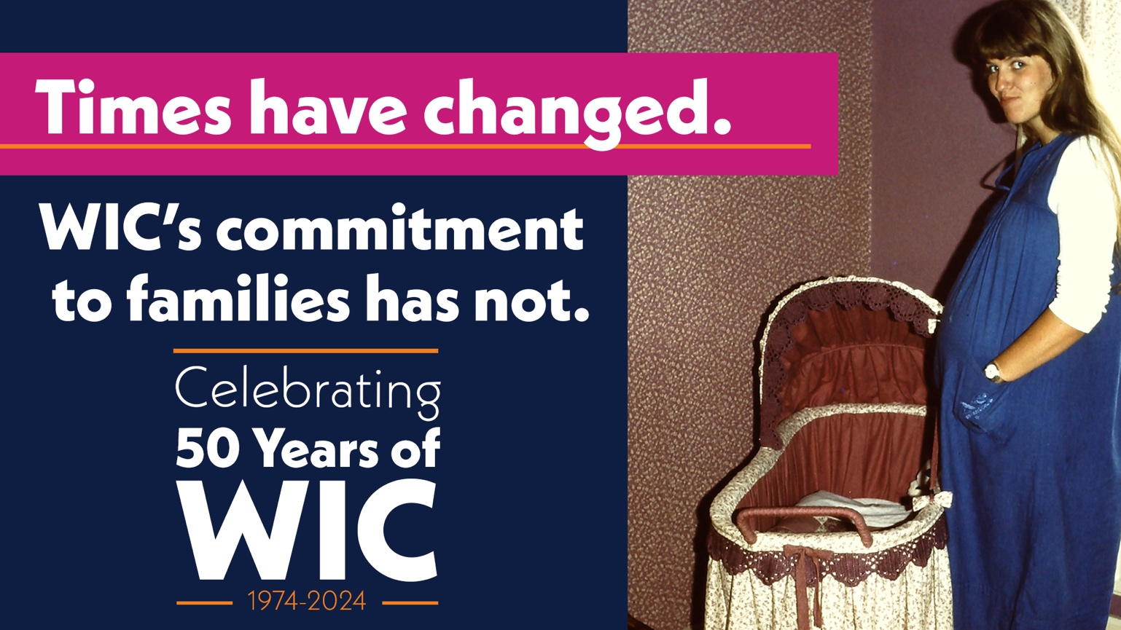

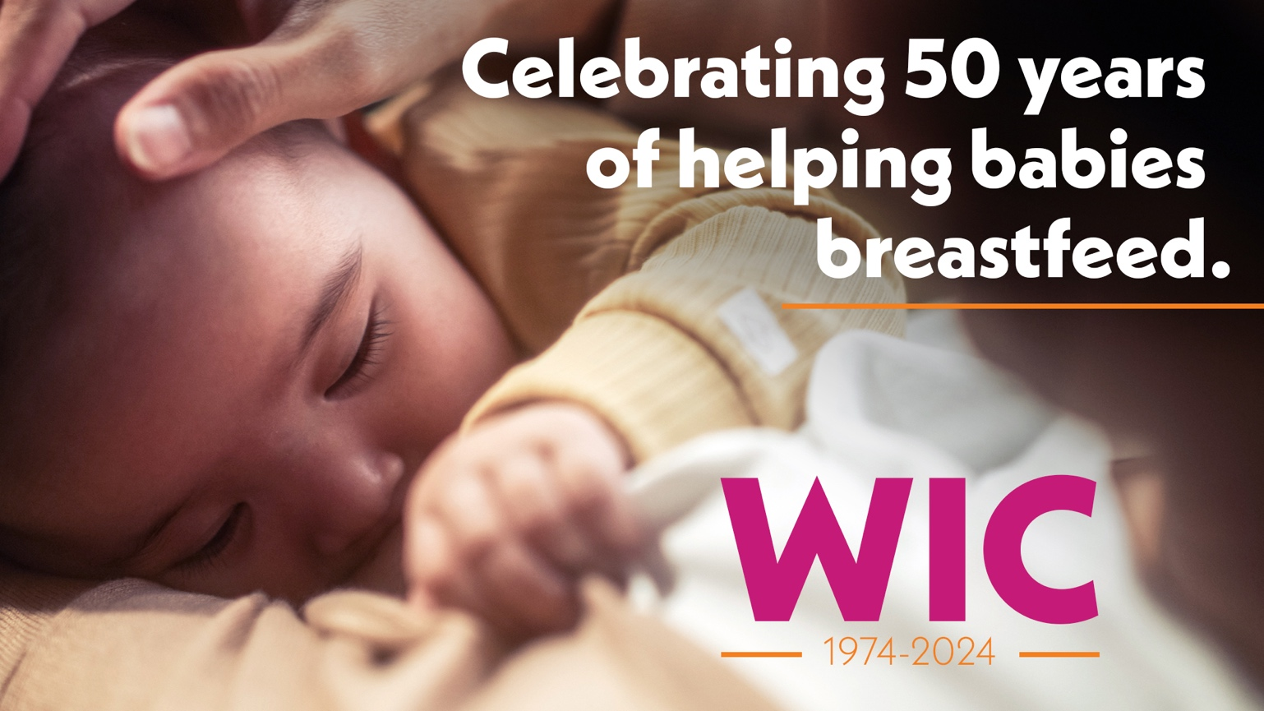

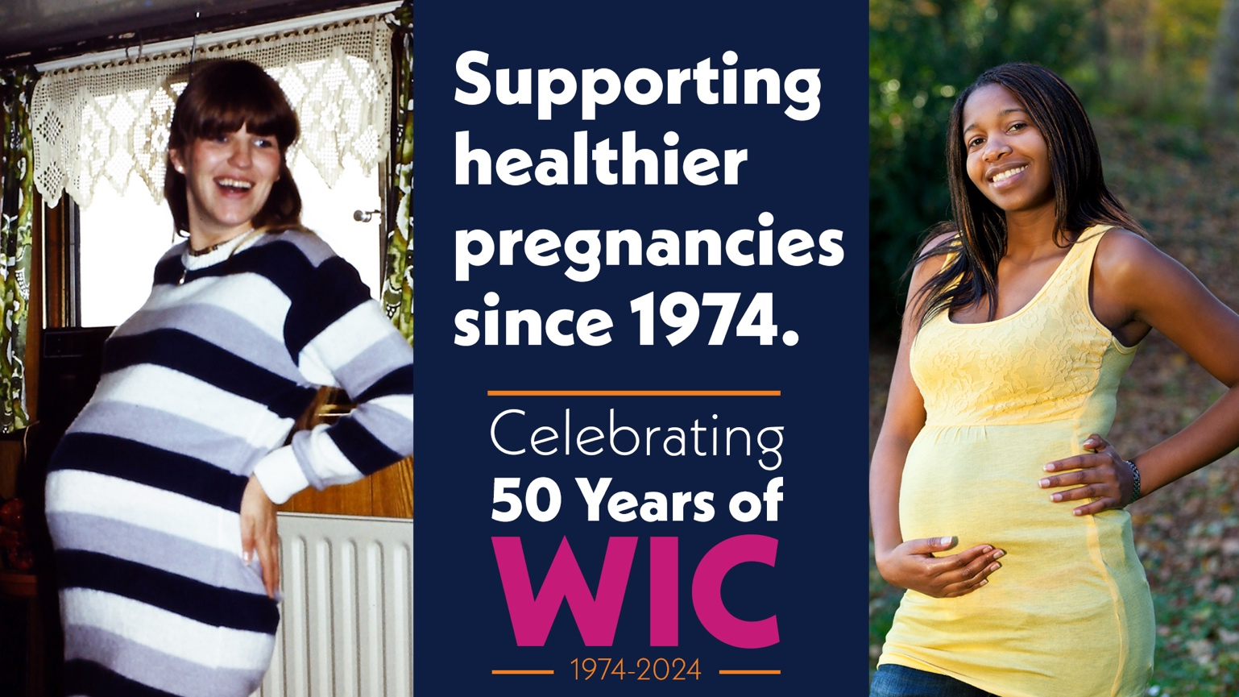

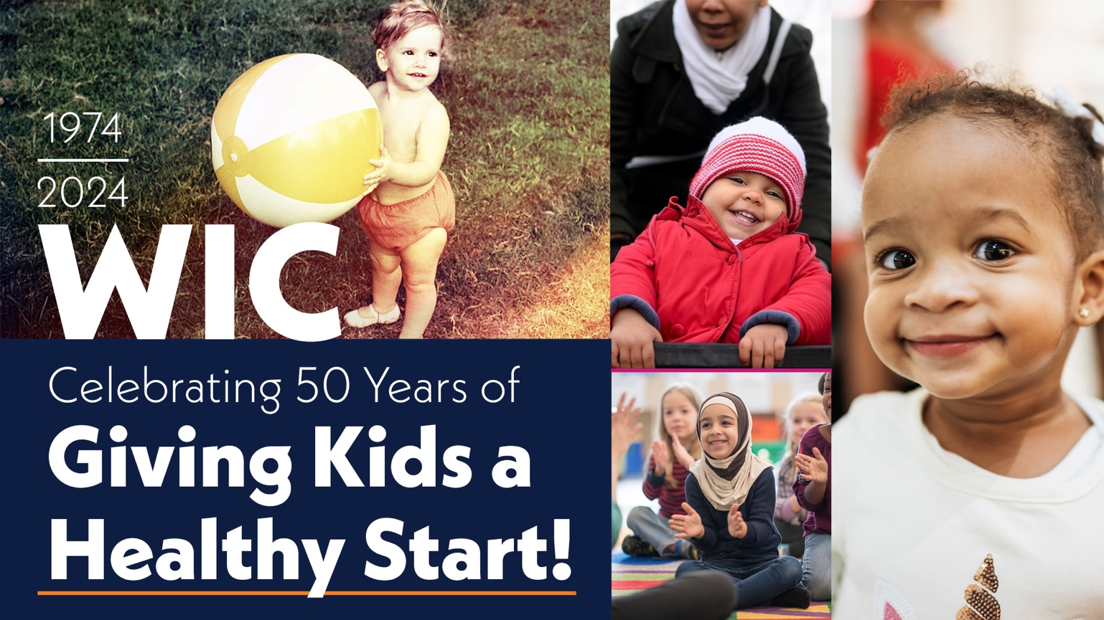

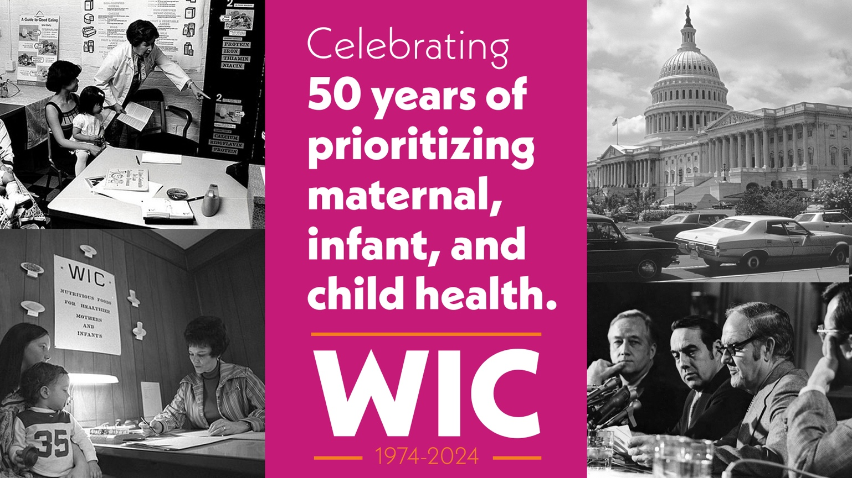

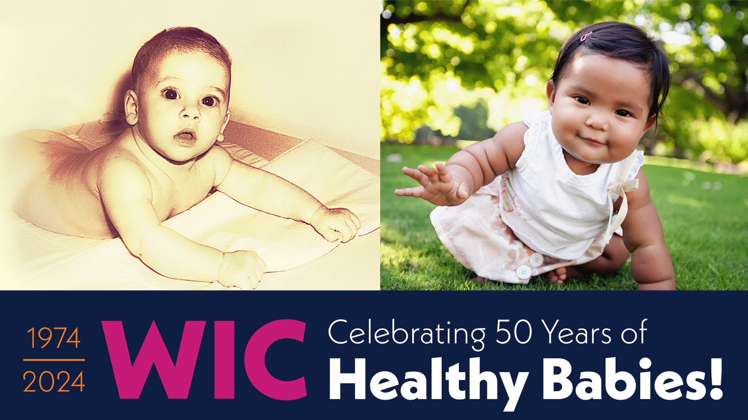

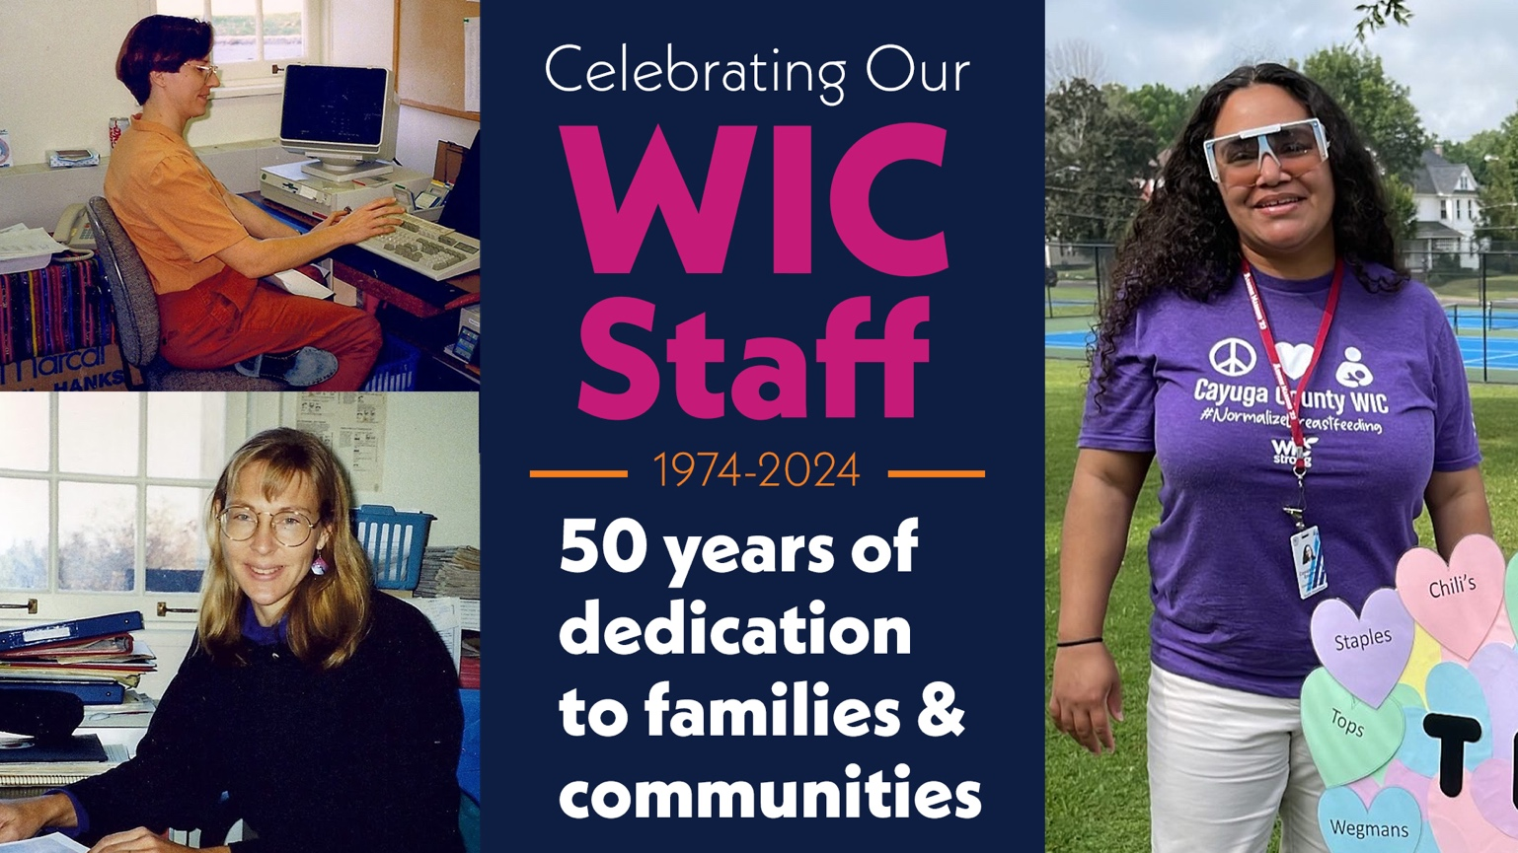

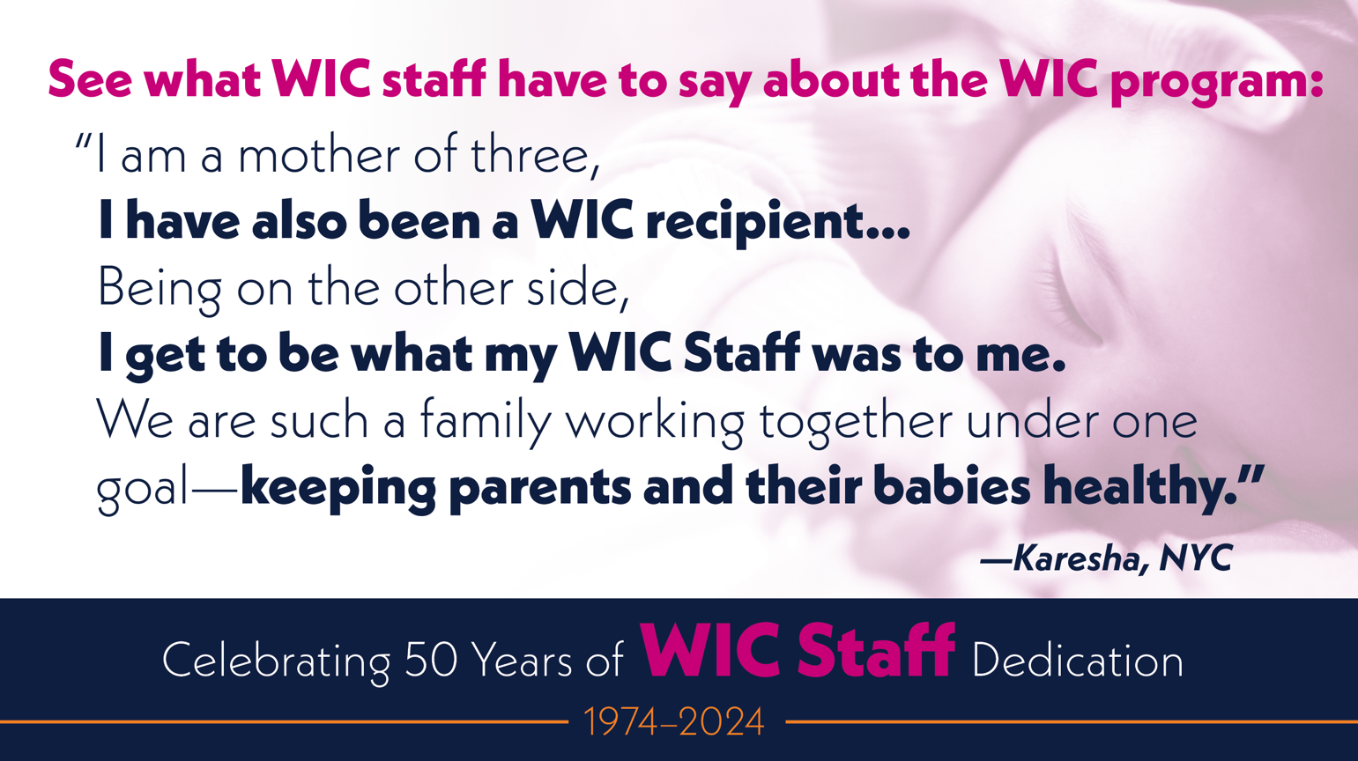
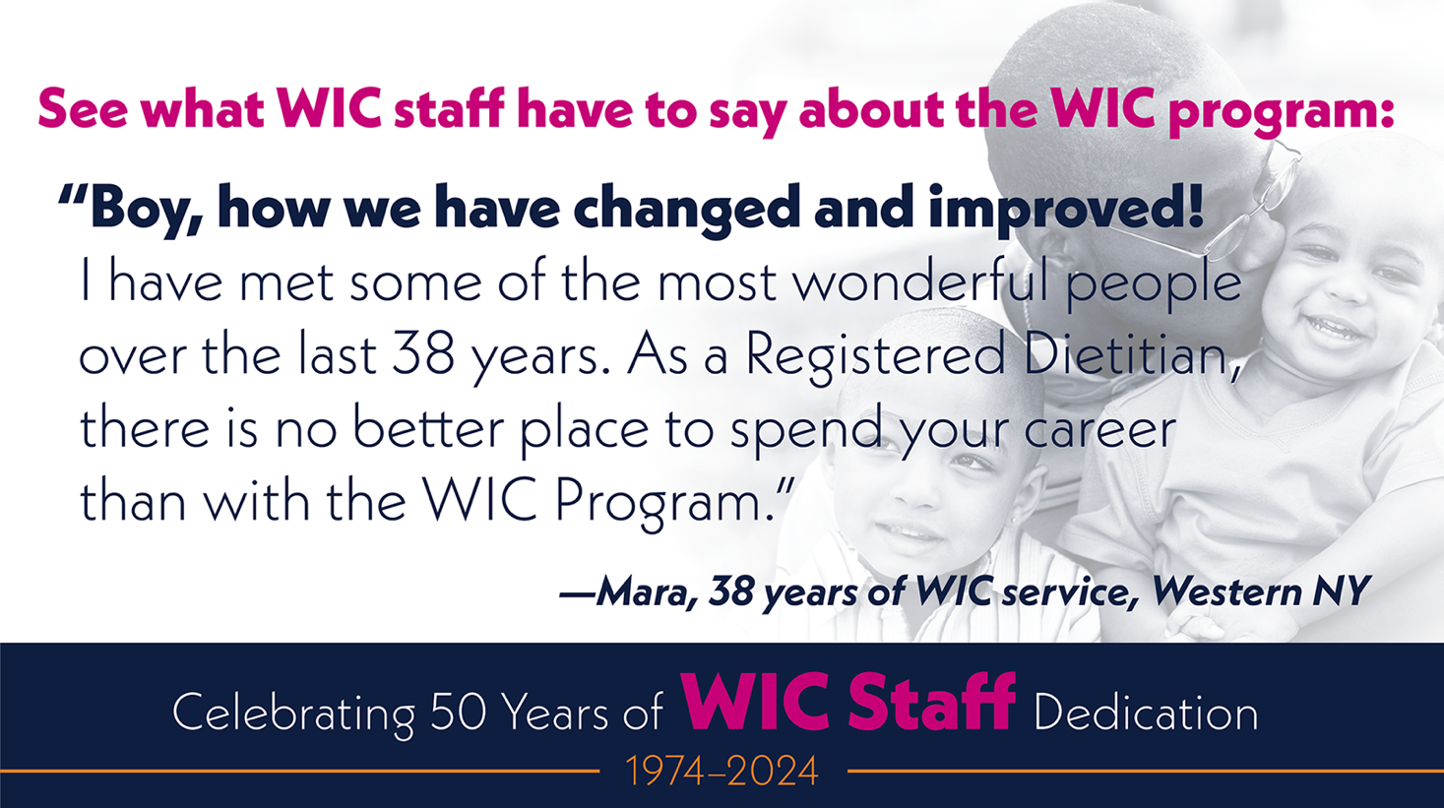

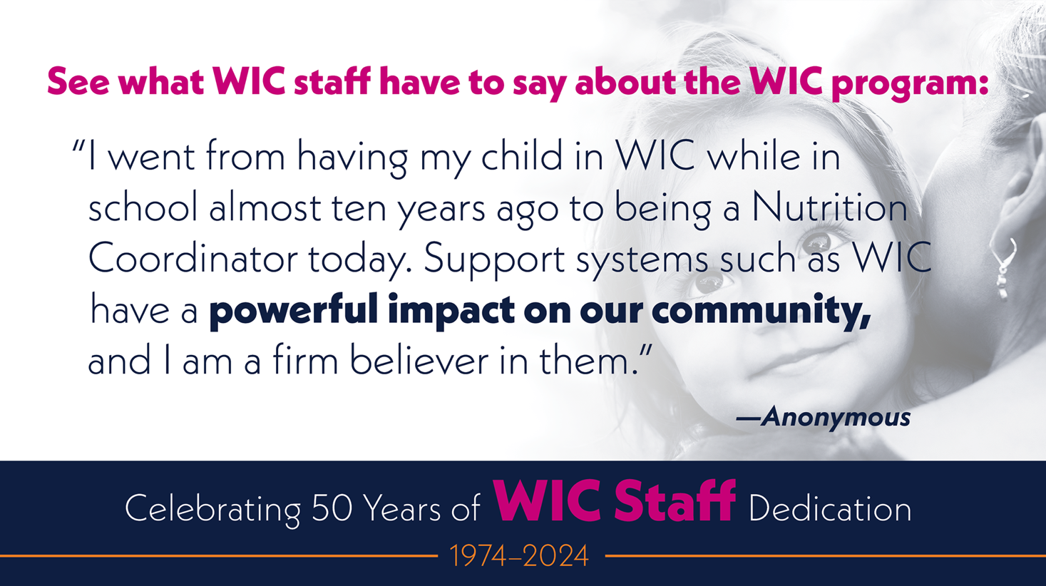

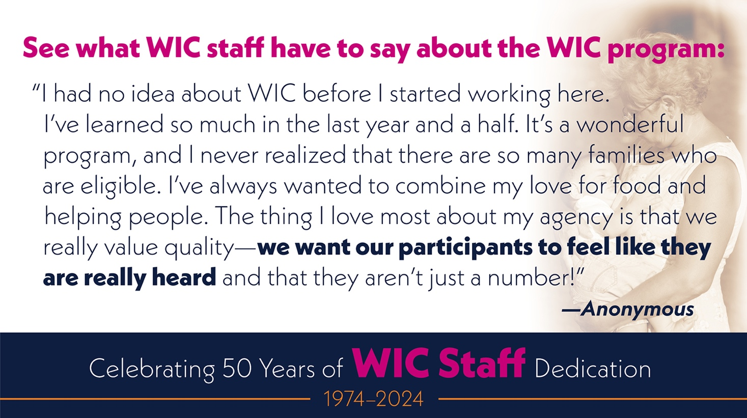

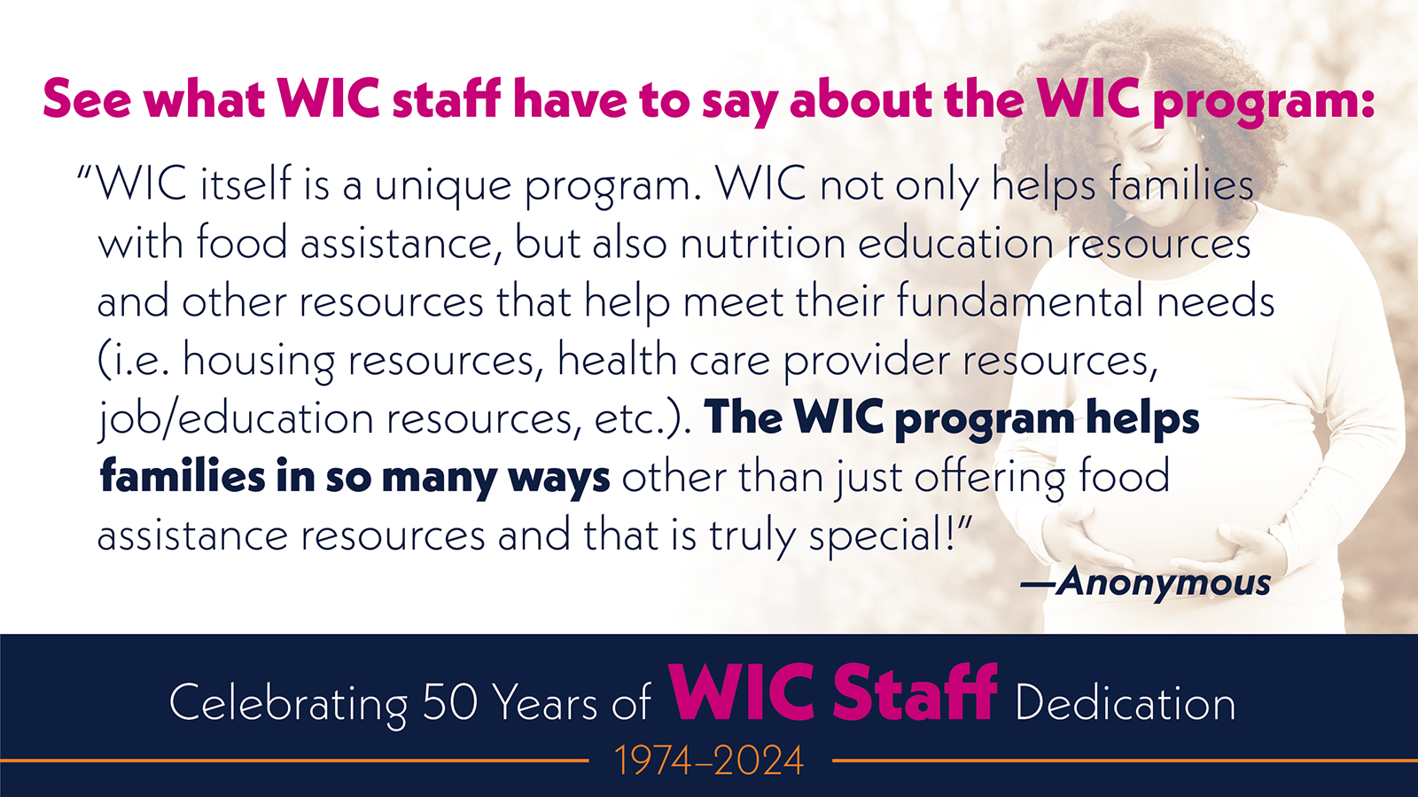
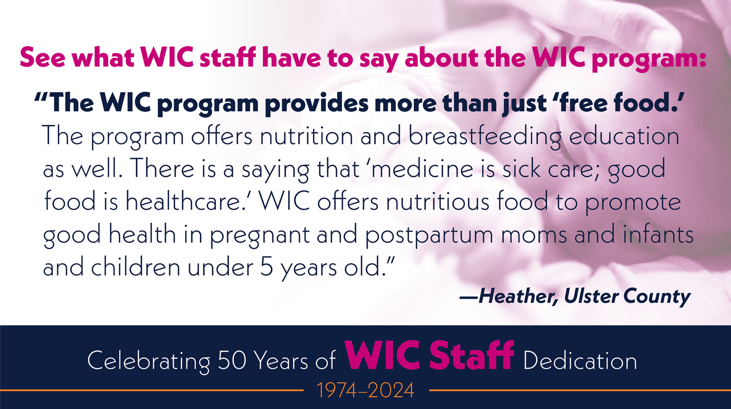

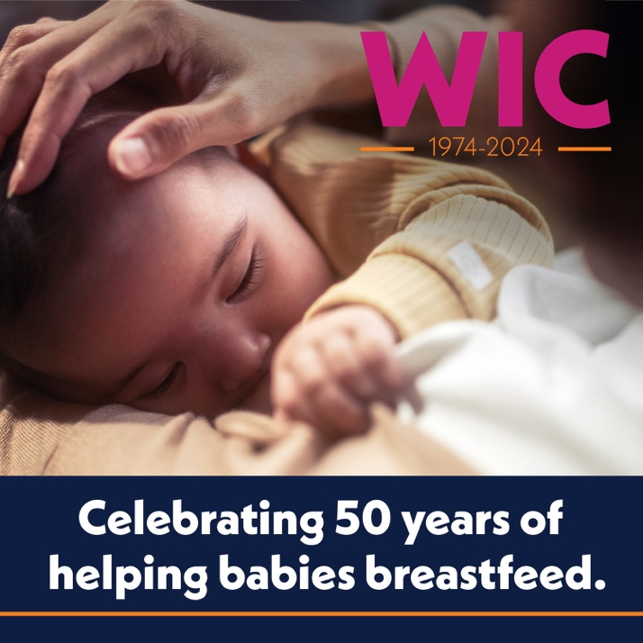
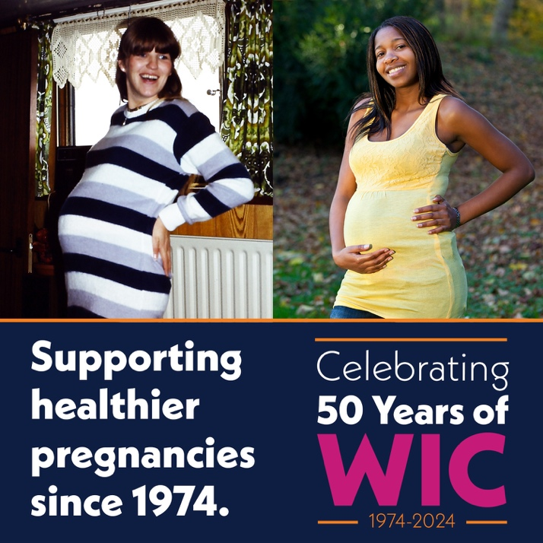
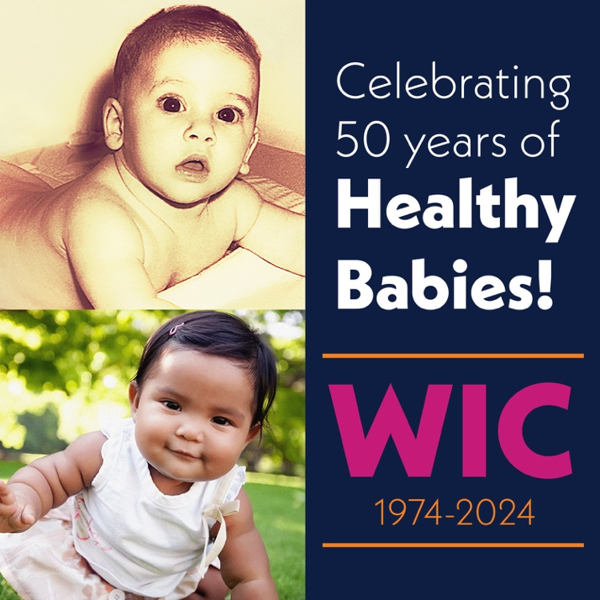

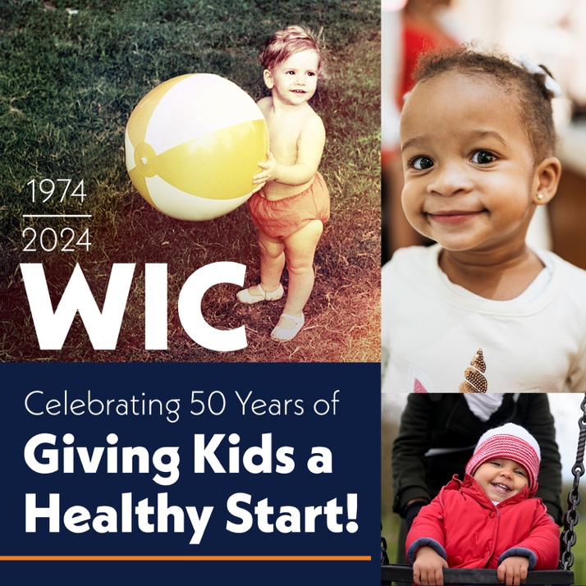
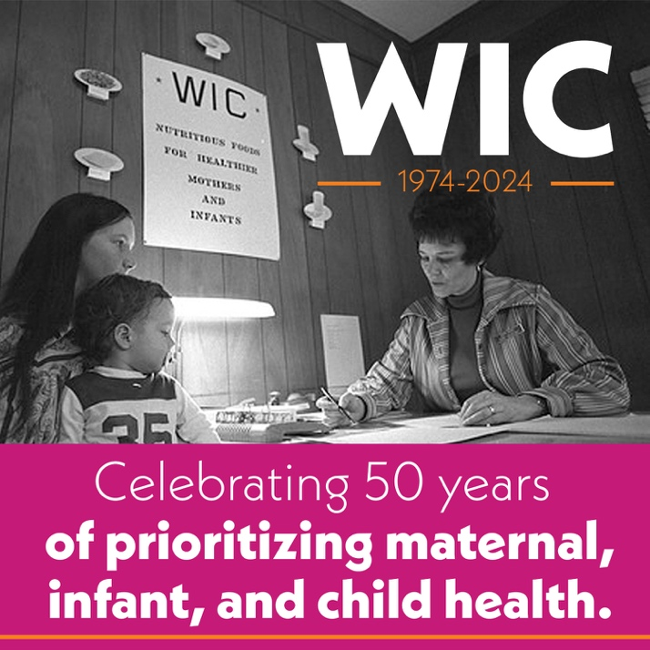

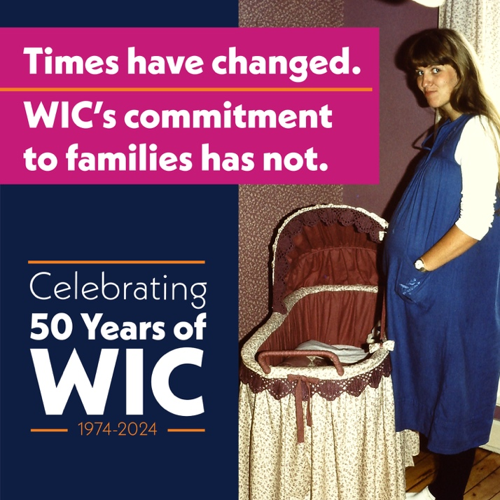

Sample Messages
Longer Captions
It’s the 50th anniversary of WIC! The first WIC office opened in Kentucky in 1974, and by the end of the year, WIC was operating in 45 states. A lot has changed in 50 years, but WIC remains committed to helping families build bright futures for their children. Join us in celebrating WIC’s incredible 50-year journey! Chat with Wanda at WICHelpNY.org to learn how WIC can help your growing family and get connected with a WIC office.

On the 50th anniversary of WIC, we honor the program's impact on the health and well-being of New York's children and families. The first New York WIC agencies opened in 1974. Five decades later, WIC provides essential health and nutrition support to more than 400,000 New Yorkers a year. If you are pregnant or raising children under age five, chat with Wanda at WICHelpNY.org to learn about WIC and connect with a WIC office near you.

WIC was created 50 years ago in response to the crisis of early childhood hunger. Today, WIC is a cornerstone of public health. Beyond healthy food, WIC provides nutrition education, breastfeeding support, and connections to other helpful programs and services. As we celebrate WIC’s 50th anniversary, we honor its success in helping families lay the foundation for lifetime health. Chat with Wanda at WICHelpNY.org to learn about WIC or connect with a WIC office.

For half a century, WIC has been essential to the health and well-being of women, infants, and young children. Decades of research show WIC’s incredible impact. WIC leads to longer pregnancies, higher birth weights, improved brain development, healthier diets, and more. This year, WIC is celebrating 50 years of helping families give their kids a healthy start. To learn more about WIC or connect to a WIC office near you, visit WICHelpNY.org and chat with Wanda.

Raising kids today looks a lot different than it did 50 years ago. Through it all, WIC has provided steady support to families during pregnancy and in the critical years of early childhood. This year WIC celebrates 50 years of success in nourishing children, transforming lives, and creating a healthier next generation. Chat with Wanda at WICHelpNY.org to learn more about WIC or connect with a WIC office.

On WIC’s 50th anniversary, we celebrate exciting new options that give families easy access to healthy food and nutrition support. Remote services, phone appointments, online nutrition education, and the eWIC shopping card allow families to participate at their convenience. Visit WICHelpNY.org and chat with Wanda to connect with a WIC office near you.

WIC is known for putting healthy food on the table for young children, but did you know it’s also one of our nation’s largest breastfeeding support programs? WIC provides access to breastfeeding experts, peer-to-peer support, extra food to support lactation, and other helpful resources to breastfeeding parents. On its 50th anniversary, we celebrate WIC’s breastfeeding support that has helped millions of families succeed on their breastfeeding journey. To learn more about WIC or find a WIC office near you, chat with Wanda at WICHelpNY.org.

Since it began 50 years ago, WIC has become one of the nation’s most important public health programs. WIC supports people during and after pregnancy and from birth to age five—times when access to health care and nutritious food is critically important. On the 50th anniversary of WIC, we honor its five decades of safeguarding the health of children and helping families build brighter futures. To learn more about WIC or find an office near you, chat with Wanda at WICHelpNY.org.

For five decades, WIC has nourished the next generation with healthy food and nutrition support. Kids who participate in WIC have better access to healthcare, more nutritious diets, improved cognitive development, and higher academic achievement. On the 50th anniversary of WIC, we celebrate the countless healthy starts that began with WIC. To learn more about WIC or get connected to a WIC office near you, visit WICHelpNY.org.

WIC has provided vital health and nutrition support to millions of women, infants, and young children in New York State. Today we want to highlight the incredible people who make it all possible—our dedicated WIC staff. From the nutritionists sharing tips for cooking healthy meals for kids to the peer counselors helping breastfeeding moms overcome common challenges, everyone at WIC makes a lasting difference in the lives of families. On WIC’s 50th anniversary, we celebrate their commitment to the health and well-being of New York’s families. Visit WICHelpNY.org and chat with Wanda to learn more about WIC and find a WIC office near you.

Shorter Captions

The first WIC office opened in 1974. For 50 years, WIC has remained committed to helping families build bright futures for their children. From then to now, WIC has nurtured the health and well-being of young children and their families. Chat with Wanda at WICHelpNY.org to learn how WIC can help you.

The first NY WIC agency opened in 1974 and served a small number of families. Five decades later, WIC serves more than 400,000 New Yorkers a year. If you are pregnant or raising kids under age 5, chat with Wanda at WICHelpNY.org to learn more.

WIC was created 50 years ago in response to an early childhood hunger crisis. Today, WIC is a leader in public health. Beyond healthy food, WIC provides nutrition education, breastfeeding support, and more. Chat with Wanda at WICHelpNY.org to learn more.

It’s the 50th anniversary of WIC! As we celebrate this milestone, we honor WIC’s pivotal role in helping families lay the foundation for a lifetime of health. Chat with Wanda at WICHelpNY.org to learn more or find a WIC office near you.

Decades of research show WIC’s incredible impact—longer pregnancies, higher birth weights, healthier diets & more. On its 50th anniversary, we celebrate the millions of healthy starts that began with WIC. Chat with Wanda at WICHelpNY.org to learn more.

Raising kids today looks a lot different than it did 50 years ago. Through it all, WIC has provided steady support to families at critical times. This year, WIC celebrates 50 years of nourishing children & creating a healthier next generation. Learn more: WICHelpNY.org.

On its 50th anniversary, we celebrate a modern WIC. New options like remote services, phone appointments, online nutrition education, and the eWIC shopping card allow families to participate at their convenience. Chat with Wanda at WICHelpNY.org to learn more.
Did you know WIC is one of our nation’s largest breastfeeding support programs? On its 50th anniversary, we celebrate WIC’s breastfeeding support that has helped millions of families succeed on their breastfeeding journey. Chat with Wanda at WICHelpNY.org to learn more.

WIC supports people during and after pregnancy and from birth to age five—times when access to health care and nutritious food is critically important. On its 50th anniversary, we honor WIC's five decades of building healthier futures. Learn more at WICHelpNY.org.

WIC is one of our most important public health programs. On the 50th anniversary of WIC, we honor its five decades of safeguarding the health of children and helping families build brighter futures. To learn more or find a WIC office near you, visit WICHelpNY.org.

Kids who participate in WIC have better access to healthcare, more nutritious diets, improved cognitive development, and higher academic achievement. On WIC's 50th anniversary, we celebrate the countless healthy starts that began with WIC. Learn more at WICHelpNY.org.

On WIC’s 50th anniversary, we celebrate five decades of success in nourishing the next generation with healthy food and nutrition support. Chat with Wanda at WICHelpNY.org to learn more or connect with a WIC office.

WIC has provided vital health & nutrition support to millions of families in NYS. Today we highlight the incredible people who make it all possible—our dedicated WIC staff. On WIC’s 50th anniversary, we celebrate their commitment to families. Learn more: WICHelpNY.org

