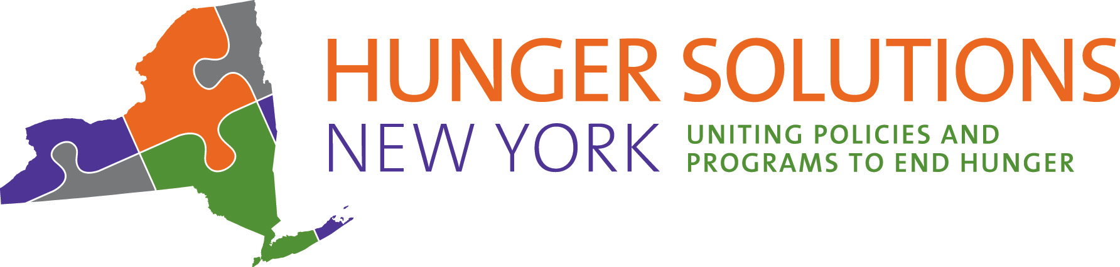
14 Computer Drive East
Albany, NY 12205
518-436-8757 PH
518-458-6068 FAX
HungerSolutionsNY.org

Pathways to SNAP for Seniors in New York State - Q&A
- Are shelter expenses required to be reported for ESAP-eligible individuals?
Shelter expenses are required to be reported for those eligible for ESAP. Under ESAP rules, households can self-attest their shelter expenses by providing a written statement of shelter costs. If the SNAP office finds the information questionable, they may request additional documentation. For more information on ESAP, please visit our webpage.

- If someone is enrolled in SNAP through NYSCAP and they need to update their information, should they update their information with LDSS or SSA?

Folks enrolled in SNAP through NYSCAP should update their information with both the SSA and SNAP offices. Local DSS offices can be found on the OTDA website. Local Social Security offices can be located via the SSA.gov locator tool.

- How do they determine if a senior is eligible for ESAP or NYSCAP, since ESAP is based on unearned income, and SSI is unearned income?

NYSCAP is an autoenrollment process. OTDA uses monthly data matching to find eligible NSYNIP/NYSCAP participants from the list of newly approved SSI recipients in NYS.

Those that meet ESAP eligibility criteria will be screened upon application submission and coded by the SNAP office to receive the benefits of ESAP. Households already receiving SNAP and meeting ESAP criteria will be placed into ESAP at their next recertification or point of contact, as long as they continue to be eligible for SNAP.

- If someone eligible for NYSCAP applies for regular SNAP, would their case be transferred to the correct office/program?

Those eligible for NYSCAP will be automatically enrolled in SNAP and there is no need to apply for SNAP. For more information on NYSCAP, please visit our webpage or view the NYSNIP/NYSCAP guide.

- When will COVID-19 SNAP Emergency Allotments end?

The current public health emergency (PHE) has been extended until July 15, 2022. Emergency Allotments will be approved on a month-to-month basis until the PHE is lifted. For the latest information on COVID-19 related SNAP changes, please visit Hunger Solutions New York’s COVID-19 page.

- Is there a higher benefit level for ESAP and NYSCAP compared to regular SNAP?
No, each budget is individualized based on income and expenses. For NYSCAP-eligible individuals, the SNAP case will open with the minimum benefit of $20 or $24. To increase that benefit, enrollees need to return the NYSCAP Case Information Collection Sheet.
For those enrolled in ESAP or regular SNAP, they may be able to increase their monthly SNAP budget by reporting out-of-pocket medical expenses to their SNAP office. Please view our Medical Exemption worksheet for more information.

