Wanda QR code
Use this QR code in your print and digital materials to connect families to Wanda,
New York State Department of Health’s new WIC virtual assistant.

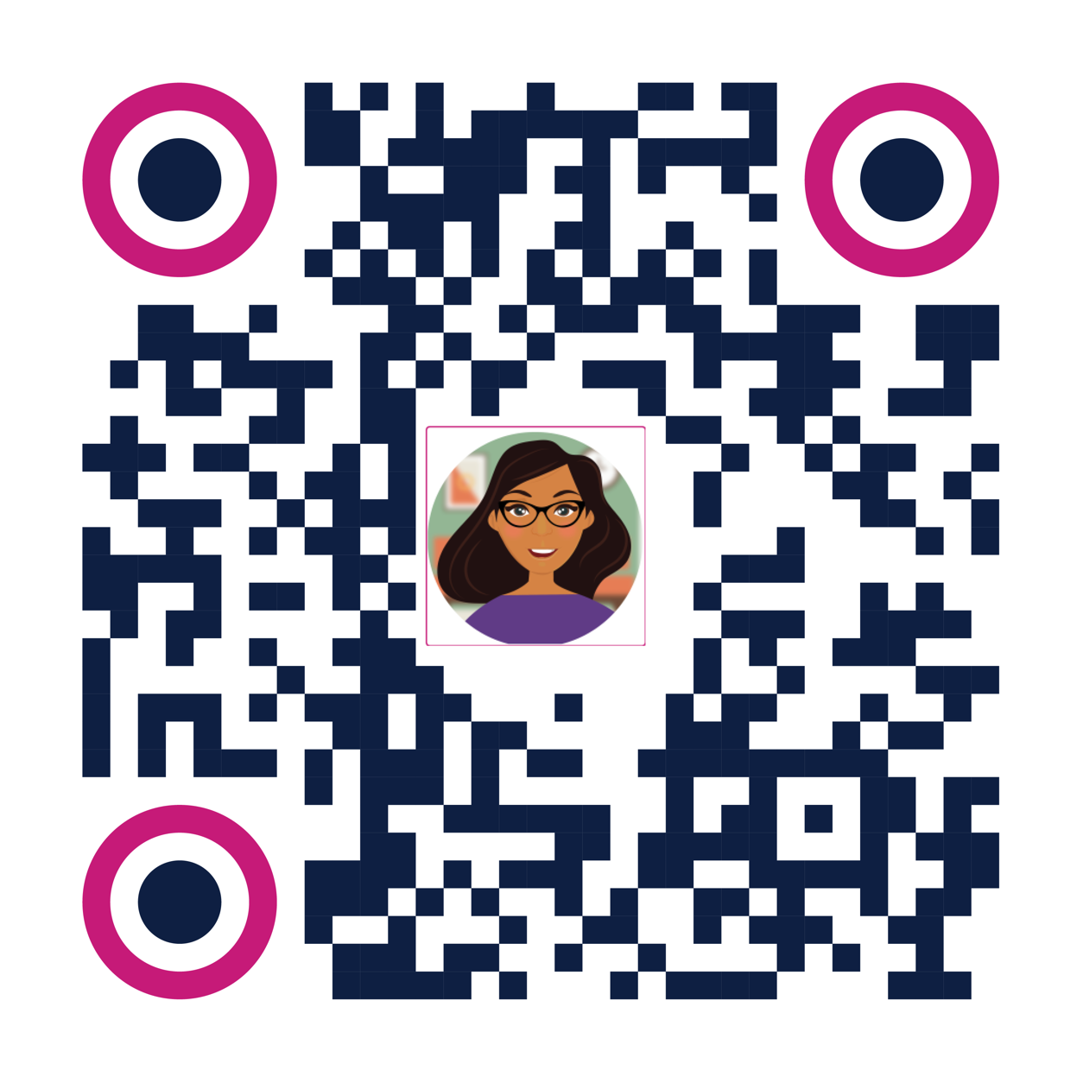

To use:
- Right-click the image and save it to your computer. You can then insert it into your own outreach materials.
- Do not skew, crop, or alter the QR code image. When resizing, maintain the aspect ratio
of the QR code.
- The QR code can be used in print or digital materials. It should not be sized any larger
than 6” x 6”.
- Always test the QR code after placing it into materials.
- If you have any questions, please contact Emily DiMuria at Emily.DiMuria@HungerSolutionsNY.org
- For more ways to promote Wanda and WIC, visit our WIC Resource Center

