Sample letter to families
Dear families,
If your child received free or reduced-price school lunch in March 2020 (when school buildings were closed due to the pandemic), they will receive $420 in food benefits from the Pandemic Electronic Benefits Transfer (P-EBT) program. This includes all children who attended a school that provided free meals to all.
Important highlights of P-EBT:
- Each eligible child will receive $420 in P-EBT food benefits, which you can use to buy food at SNAP-participating stores. Note: this benefit is for last school year (2019-2020).
- There is no application. P-EBT benefits are being issued automatically.
  - Most – but not all – families with SNAP or Medicaid already received P-EBT benefits on their EBT or Medicaid card over the summer. Visit HungerSolutionsNY.org/PEBT to learn more.
  - All others eligible families will receive a new P-EBT card in the mail. Cards are being mailed through the month of October. Please watch your mail for an envelope and card like the ones pictured below.
  - Once you use your benefits, keep your P-EBT card in the event additional benefits are issued in the future. Please note: NYS has not yet determined plans for future benefits for the 2020-2021 school year. Please do not contact the NYS P-EBT helpline or email address with questions about future benefits, as these channels are working to help families access their P-EBT benefits from the 2019-2020 school year. Watch the NYS P-EBT webpage or HungerSolutionsNY.org/PEBT for updates.
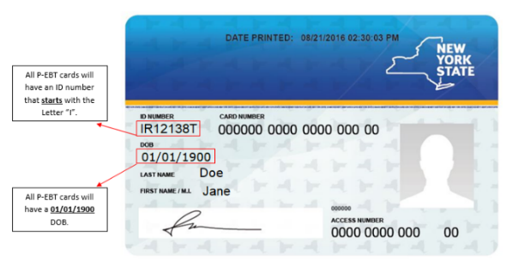
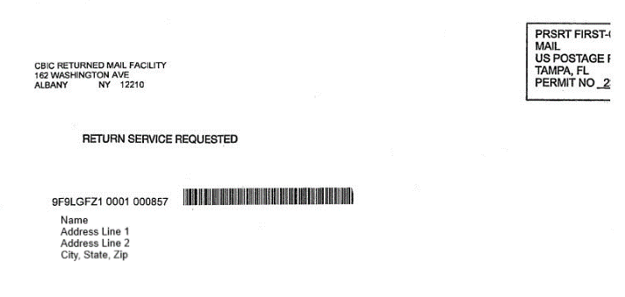

- Your immigration status does not matter for P-EBT. Using P-EBT does not affect your or your child’s immigration status. The public charge rule does not apply to P-EBT.
- P-EBT is not SNAP, and does not replace other nutrition programs. You can still get meals from school, and use other programs, like SNAP and WIC, while using P-EBT.
- Everyone who receives P-EBT should use it. Using P-EBT food benefits is good for the local economy. Benefits remain available for one year after they are issued. Please note: You cannot give your card to another person to use. If you wish to donate to help others in need, please contact a local food pantry or nonprofit organization that may accept donations of food and/or money they can use to buy food.
Visit HungerSolutionsNY.org/PEBT to learn more.
Best,
[School/Organization]

