Help promote summer meals for kids and teens!
Share these messages on social media, in newsletters, on your website, in text alerts, and more. Copy and paste or tweak as needed. Hashtags are included for social media use.
Include a graphic, too! Hyperlink the images below to SummerMealsNY.org so families can easily find information about summer meal sites. Right click the images to save them to your computer.

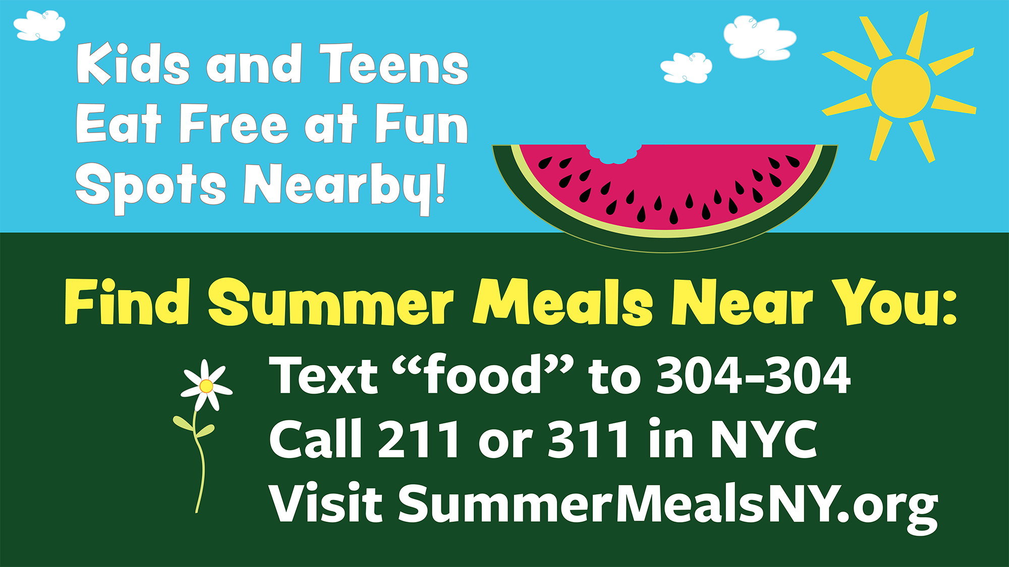

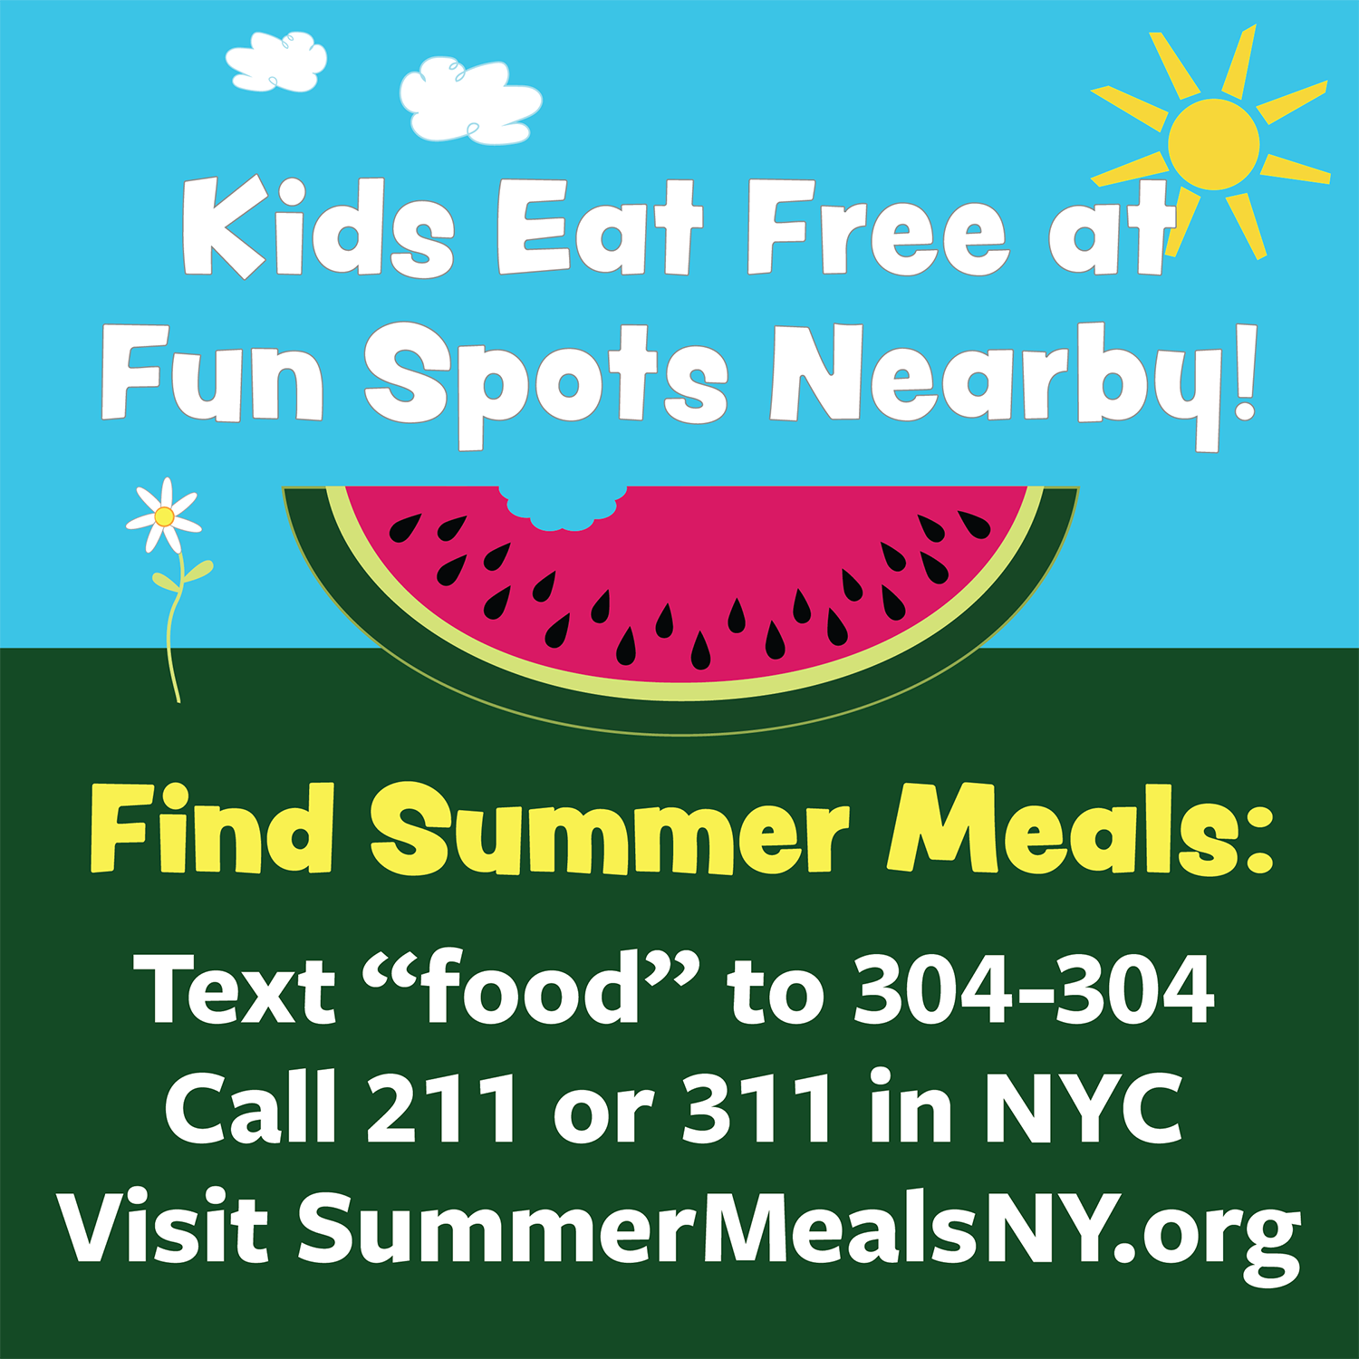

Summer break is here! Kids & teens can eat for free at thousands of places across NY. Visit SummerMealsNY.org, call 2-1-1, or text “Food” or “Comida” to 304-304 to find summer meals near you. #SummerMealsNY
Kids need healthy food to fuel summer fun! USDA partners with local schools and community orgs to serve healthy, no-cost meals to kids & teens ages 18 and under. Visit SummerMealsNY.org, call 2-1-1 or text “Food” or “Comida” to 304-304 to find a summer meal spot near you. #SummerMealsNY #SummerLearning #StopSummerSlide
Free #SummerMeals fuel summer fun! Visit SummerMealsNY.org, call 2-1-1, or text “Food” to 304-304 to find local summer meal sites for kids & teens.
We hope your family has a summer full of sun, good food, and fun! Call 2-1-1, visit SummerMealsNY.org, or text “Food” or “Comida” to 304-304 to find local places where all kids and teens ages 18 and under can get free, healthy meals. #SummerMealsNY #StopSummerSlide
Local schools & community orgs offer healthy summer meals for all kids & teens – at no cost to you. Visit SummerMealsNY.org, call 2-1-1, or text “Food” or “Comida” to 304-304 to find a site near you. #SummerMealsNY
Kids & teens can get free, healthy #SummerMeals in our area! No sign up needed — just drop by when meals are served. Visit SummerMealsNY.org, call 2-1-1, or text “Food” to 304-304 to find a summer meal site. #SummerMealsNY
Summer break is here! Help all kids have a fun and healthy summer by texting “Food” to 304-304 or visiting SummerMealsNY.org to learn who serves no cost #SummerMeals in your area.

