Sample posts – use with the card/envelope images below:
- All NY kids who got free or reduced-price school lunch in March 2020 will receive $420 in Pandemic-EBT food benefits. You do not need to apply; benefits are being issued automatically. Many families with SNAP or Medicaid already received P-EBT benefits on their EBT or Medicaid card. All other families will get a new P-EBT card in the mail – cards are being mailed throughout October. Watch your mail for an envelope and card like the ones below. Learn more: HungerSolutionsNY.org/PEBT
- Pandemic-EBT is a new program providing $420 in food benefits to all kids who got free/reduced-price school lunch as of March 2020. Many families in [New York/city/county] are starting to receive P-EBT cards in the mail, or already received P-EBT benefits on their SNAP or Medicaid card. Learn more: HungerSolutionsNY.org/PEBT
- If your child got free/reduced-price school meals in March 2020, you will receive $420 in #PEBT food benefits. No application needed. Benefits will be issued automatically on an EBT card. Don't have an EBT card? Watch your mail for the envelope below. HungerSolutionsNY.org/PEBT
- Post for schools where all children will receive P-EBT (e.g., CEP or Provision 2 schools):
All [school/district] students will automatically receive $420 in #PEBT food benefits on a new or existing EBT card. No application needed. P-EBT benefits are not limited by immigration status and public charge rules do NOT apply. Learn more: HungerSolutionsNY.org/PEBT

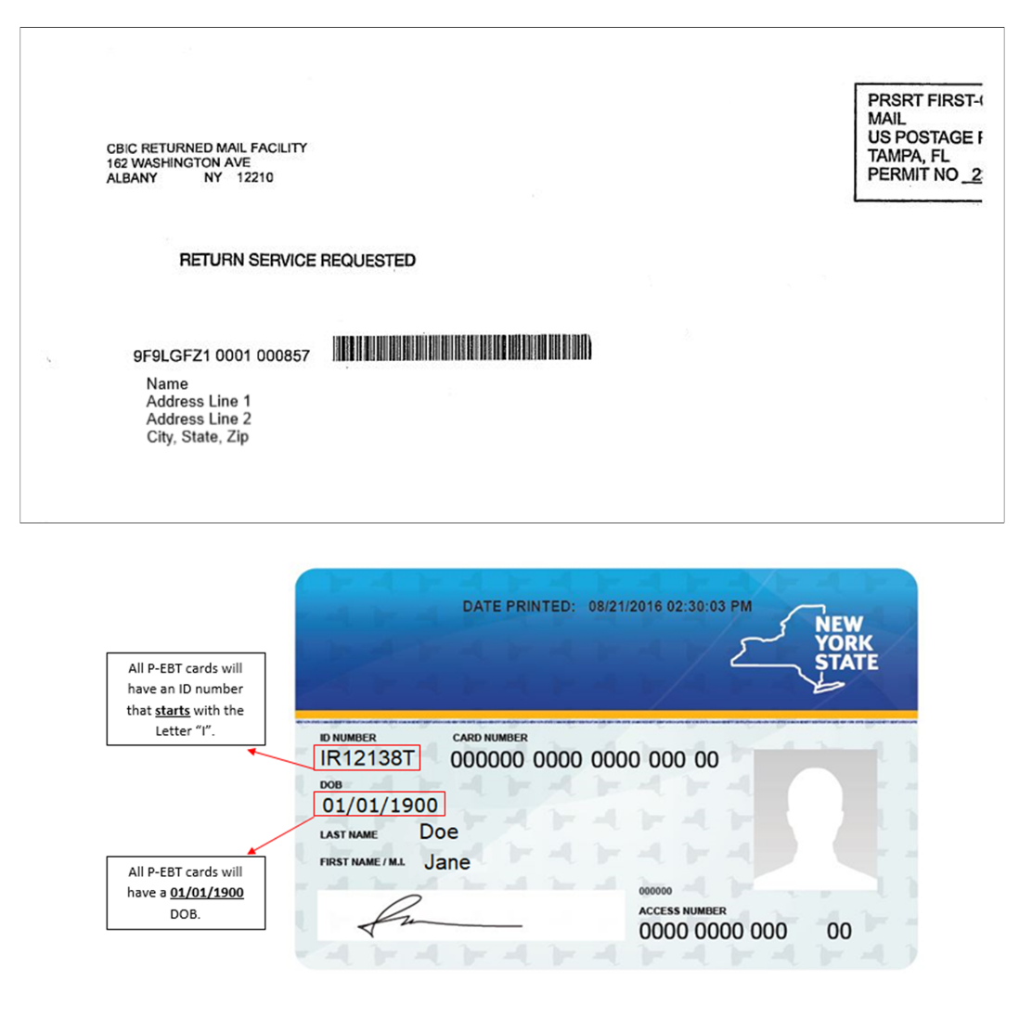
Accompanying image:

